Willful Disobedience

An Anarchist Publication

Volume 5, number 1, Spring/Summer 2004

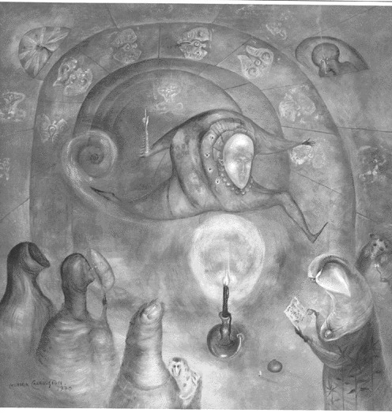

… the time has come to say things without mincing words.

LIFE IS ELSEWHERE

Deprived of all freedom except for that of consuming commodities, soaked in blood, to the extent granted, we are ourselves reduced to commodities exchanged at discount prices for an intolerable survival.
Spending our existence in forced and alienating activity that is mostly useless and harmful, measured by a time that doesn’t belong to us, we scrape together just about enough to fool ourselves into thinking we are living.
Every decision is already made by those who have taken the direct determination of our lives away from us and use it against us to safeguard their power through control and repression.
In the domination of the state and capital, order and peace are nothing but a systematic attack against joy.
Resignation is the best lubricant for this factory of death called society.
To those who instead desire to live freely and passionately, this desert of Plexiglas can only recall the compelling need to destroy it.
We are among those who feel this way, sharing ideas that are poisonous to god, state and money; an arsenal capable of rekindling the awareness of not being a code and of unmasking the tragic farce that makes us into squalid simulations of ourselves.
The critique goes deeply into it all with radicality because the conflict between power and those who want to bring about its disappearance is radical; between the chains of the masters, bureaucrats and executioners and the shears of the individual who, starting from his indispensability, wants it all back again.
Paper that remains such in the talons of voluntary servitude, but that becomes a cure-all for the rebel mind.
May theory and practice support each other in the damned adventure of the social war!

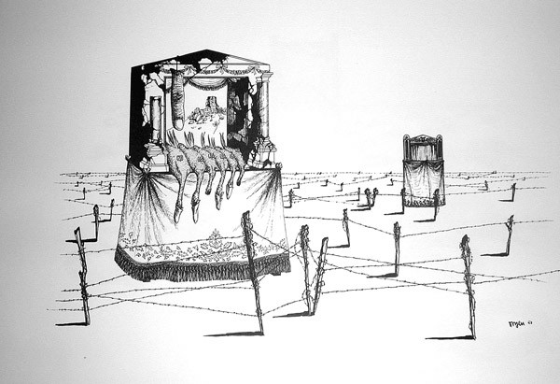

A Few Words:
On the World in Which We Live

As anarchists, we do not define our aims or our projects within the limits imposed by the world in which we live. Revolution aims to overturn these limits, to destroy all that stands in the way of realizing our desire to make our life together our own. But this puts us in conflict with the world in which we live, and it is here that we live out that struggle. So it is necessary for us to examine this world, to analyze the social relationships that are in operation and to come to an understanding of what is at play on the field in the ongoing social war.
So let’s take a look at this world. What we are facing can seem overwhelming. The war against Iraq, the vicious conflicts in Africa, the ongoing Israeli attack against Palestinians are just a few of the more blatant horrors of this world. But it is necessary to try to see a larger picture in order to put these situations in context.
The world in which we live is dominated by a single social order, the current face of western civilization, the order of the state and capital. This social order aims toward total domination, but it would be a mistake to think it has achieved this. Although it has spread its network of control across the entire globe, it is spread thin. At its margins and beneath its vision other ways of being and relating continue to exist – at times in open conflict with this order. Its spread across the globe has forced it to develop decentralized methods of social reproduction and control that form a bureaucratic and technological network – with the technological aspect becoming increasingly dominant. The relationships of domination and exploitation are built directly into this network and so it is not really under anyone’s control, not even that of the rulers of this world. Its control is not only based on the technological monitoring of our activity, but more significantly lies in the fact that the technological system makes us dependent upon it while defining the parameters of our interactions with it within very narrow limits. In short, it makes us cogs in the social machine.
But this network is stretched very thin. It is fragile and full of holes. Malfunction and disaster are basic norms of daily existence within this world. As long as they and their power are not threatened, the rulers of this world don’t really care. Their social and environmental reforms merely ways to try to extend the natural and human resources available for them to exploit.
In the meantime, the impoverishment of the exploited is advancing on all levels. As always, we take the brunt of every economic catastrophe. And for us, the current advance of capital across the globe is itself a catastrophe. As it spreads to the “less developed” areas of the globe, millions are being forced to leave the land on which they made their lives and head for the cities. Gigantic shantytowns develop around the growing metropolises of the world filled with people forced to scrape by, selling themselves cheap to anyone willing to pay and engaging in whatever illegal activities are necessary in order to survive. Many decide to immigrate in hope of find something better. Instead they just find more exploitation and poverty, along with harassment by the cops and potential imprisonment for the lack of a slip of paper. The rulers use this pool of cheap labor that can be hyper-exploited as blackmail against the rest of the exploited in order to impose worsening conditions on every level.
In fact, precariousness on all levels is the norm for the exploited and dispossessed of this world. Precariousness at the job, precariousness about whether one can pay the rent or the bills, the precarious state of the environment and of our health due to environmental pollution and toxins in our food.
The common precariousness shared by the exploited could provide a basis for people to intertwine their struggles to transform their existence. Current developments in capitalist society are simply making existence less and less bearable for more and more people, and if we start to see how our struggles against this world could unite, that might prove disastrous for the ruling order. The masters of this world are quite aware of this and have been openly practicing preventative repression for years. The events of September 11, 2001 simply gave them an excuse to openly codify what they were already doing.
But the existence that the ruling order is imposing continually meets with resistance. In much of South America struggles of the poor and of indigenous people have shaken up the social order. Argentina, Bolivia, Ecuador, Peru and so on have seen ongoing revolt at various levels for years. There has been an ongoing insurrection in Algeria, centering in – but not limited to – the Kabyle region since April 2001. We hear as well of rebellions in Korea and of indigenous people of Canada resisting state intrusion. Though it is difficult to know what exactly is going on in Iraq through the media fog, the people there have been steadily resisting the American occupation. It seems that some aspects of this resistance may escape the limitations of religious and nationalist struggle.
Another significant point of resistance is the return of the wildcat. Over the past several months, transit and airline workers in Italy, dock workers in Spain, medical workers in Canada and independent truckers in L.A. and Oakland, just to name a few, have staged wildcat strikes, reviving a form of self-organized struggle that seemed to have nearly vanished. Strikers have used blockades and sabotage as weapons in these battles, and sabotage is also appearing more frequently in the midst of official strikes, much to the chagrin of union officials.
Blockades are proving useful in a wide variety of struggles. In Bolivia, Argentina and Algeria blockades of major highways have played a major role in the insurgence. In November of last year, people in the Basilicata region of Italy organized massive blockades of the whole reason to stop the building of a nuclear waste dump there. Their struggle was successful and, from what I understand, they have continued to hold assemblies (like those they used to organize the blockades) for horizontal discussion of their lives and the problems they face.
In addition, the concentration camps that every democratic state has built for imprisoning undocumented foreigners have not been places of quiet resignation. Hunger strikes, protest, riots and escapes are frequent. There have been several incidents in which protesters outside of the camps have aided escaping immigrants. It is an area in which external solidarity is absolutely necessary.
There is of course much else to say about the world in which we live: the many daily humiliations imposed on us from surveillance cameras to the passionless courtesy (or rudeness) of transactions of exchange; the many daily, often hidden, rebellions against this. But this paints a very general picture of some of the realities we need to take into account in developing our theory and practice of revolt. As an anarchist with a critique of civilization, I recognize that if I cannot make my critiques relevant to the realities of this world, if I cannot put them into practice in the struggle against exploitation and domination here and now, then they are of little use. This involves exploring the connections between various struggles, the places where they can weave together. It involves a capacity to recognize how solidarity can operate as an expression of the need and desire we each have to take our lives back as our own. The world in which we live needs to be destroyed so that the possibilities for creating our lives on our own terms open up. It is up to us to figure out the weak points to attack and to discover our accomplices in this crime called freedom. Being aware of the reality we face and the battles now being waged against it is a first step.

THE WILDCAT ROARS AGAIN

It seems so long since the specter of the wildcat strike has cast fear into the hearts of the masters of this world. One might have thought the roar of the wildcat was never to be heard again. Certainly things have changed drastically since it pierced the air so fiercely in the 1960’s and 1970’s. The position of the exploited has become very precarious on all fronts. Those who have managed to continue to live on their own terms in small communities living on the land are being dispossessed in huge numbers, forced into the shantytowns around quickly expanding cities or into immigration often without documents. In the West, the exploited frequently find themselves forced to take shitty, poorly paid jobs, to work for temp agencies and so on. The restructuring of work has greatly reduced the usefulness of unions for managing worker frustration and so reduced their negotiating power.
For years now, with only a few exceptions, these circumstances seem to have stifled collective workplace revolt. But the desperation of precariousness can turn into anger and action. The past several months have shown that the exploited aren’t all resigned to accepting their fate or leaving it in the hands of representatives who have proven over and over again that their only real aim is to maintain their position of petty power within the social order. And so it seems the wildcat is back on the prowl. From Italy to China, from Iran to LA, unionized and non-unionized workers have been taking their own action without depending on unions or letting union officials decide the aims or methods of struggle. Of the numerous accounts I have read, most are full wildcat strikes. Some are strikes called by unions in which the workers refuse to play by the rules, making use of sabotage, ignoring back-to-work orders or continuing to strike after the union has signed an agreement and declared the strike over. Blockades, occupations of government or company property and battles with the police have not been uncommon. There is also at least one incident in Japan where disgruntled airport workers did not strike, but carried out sabotage to express their anger. A few of these struggles stand out for different reasons.
In Italy, from December 1 of last year through January, transit workers in Italy staged a number of wildcat actions. The unions had called for legal one day strikes because a new contract was due to be negotiated. Legal strikes of transit workers in Italy require that there is full service during the peak hours. From the start, there were those who had no interest in either legality or following the lead of the unions. On December 1, the Milanese transit workers decided to go wildcat rather than abiding by the rules. On the next day of action, this spread to several other big cities in Italy, and when the union signed a sell-out contract on December 20, Italian mass transit was nearly completely shut down. Anarchists and other revolutionaries expressed solidarity with flyers reminding people to take advantage of this time off from the everyday humdrum that the transit workers were offering them. In addition, there was sabotage of ticket machines. At first there was some user hostility against the strikers, but as time went on this changed and during another wildcat in Milan in mid-January, other Milanese workers went out on solidarity strikes and the road to the airport was blockaded. In the course of this struggle as circumstances demanded, sick-ins and work-to-rule tactics were also used.
Another interesting incident happened last April when workers for the state electric and gas company went on strike throughout the country. In Paris they set up a blockade and attacked the offices of the electric company with light bulbs. But what is most interesting is that the workers in many places disconnected power, but often quite selectively. It was not uncommon for local officials and public buildings to lose their electricity while people whose electricity had been cut off because they hadn’t paid their bill would find it restored free of charge. The union that claimed to represent the workers, of course, condemned these actions.
In British Columbia, in Canada, hospital workers have been involved in a self-organized struggle against lay-offs and cut-backs for months. Wildcat strikes, building occupations and direct action were frequent and finally the union felt compelled to act (after 6000 lay-offs), calling an official province-wide strike. But when “back-to-work” legislation was applied, the hospital workers refused to comply. So on April 29, the strike became illegal. Almost immediately hydro workers at the dams walked off in a spontaneous solidarity wildcat strike. In addition, anarchists in BC took action in solidarity, ranging from posters encouraging a general wildcat strike to participation in marches and probably various other actions.Over the next few days, more and more workers and students of all sorts joined in the strike. Apparently on May 3, the union signed a sell-out contract with the Liberal government of BC, but strikes continued throughout the day, and the next day high school students in Prince Rupert staged a walkout and march in solidarity with the hospital workers.
There have been a few other wildcat and illegal strikes of some note that I will just mention in passing. Dockworkers in Spain staged a significant illegal strike in January and February involving the blockading of docks, the occupation of company offices and conflicts with the police. In early April, subway workers in Buenos Aires succeeded in winning a desired pay raise through a wildcat strike involving blockades where necessary to prevent the management from running the trains. And in late April and early May, contract truckers who work on the docks in LA and Oakland, California, staged wildcat strikes. These workers are among those who are legally defined as “self-employed contractors” and thus are not covered by labor laws.
If this recent surge in wildcat actions is an indication of future struggles, anarchists can’t just ignore it. The purists can “critique” the limited demands of the workers carrying out these actions, thus keeping their hands clean. But as with most struggles, the immediate demands are rarely particularly interesting, reflecting the immediate needs of those involved. What is interesting is the use of self-organized methods of acting that carry the possibility of moving the struggle beyond the limits of its immediate demands. It is here that anarchists may have something to say, like the comrades in Italy who posted flyers reminding people of the gift of time the striking transit workers were offering them (see the article below) and describing practical ways of expressing solidarity and those who sabotaged the ticket machines. It is hard to say where this latest surge of wildcat activity will go, but the roar of the wildcat is always good to hear and it is up to us to figure out how to act in complicity with what is liberating in these struggles.

A favor to return

The wildcat strike has come back. We almost didn’t know what it was anymore, we had lost the memory of it.
And yet for many years it had made the masters’ knees tremble, causing the rediscovery of the joy and pleasure of insubordination among those forced to work. Finally, a handful of irreponsibles have decided to dust off this old friend of the enraged, pulling it out of the box where responsible adjustment and civil democratic dialogue had buried it for many years. But these irresponsibles have a particularity: they are the drivers of the streetcars and buses that deposit us at work, at school or at the supermarket every day. And without them, everything stops. This is the impudence that has caused the politicians and masters to get so furious, and it is also the same thing that has managed to fill the heart of so many of the exploited who have seen in the transit workers a rediscovered possibility. A kick in the stomach to imposed rules, a way out from the fraudulent limits of union negotiations, an effort that, for once, has tried to start from self-organization and not from the policy tables.
The transit workers have banished the union hypocrites, accustomed to speaking in the name of all, to the role that lies within their competence: that of the bureaucrat, of the punctilious compiler of lists with the names of rebels (participants in the strikes and pickets), of the attentive and devoted complicit guide of the police. Thus, for once, the unions – that had guaranteed the government that they could control and manage the struggle – have found themselves with a fistful of wastepaper, the union cards that many workers have torn up.
For the first time in many years, the wildcat has forced the regional governors to mobilization. And when it is the police who make the streetcars run, everything becomes clearer: in social struggle everyone gets what s/he manages to conquer through force. On one side there is the force of the exploited who organize themselves autonomously and on the other side that of the state and the masters, of the police and propaganda.
The government for its part has done no more than repeat the same old song, good for any and every season: “the transit workers are urban terrorists”.
In the meantime, the struggle of the irresponsibles continues and extends itself, armed with the solidarity that has marked it from the beginning. The wildcat strike that began in Milan has reached the majority of Italian cities – despite criminalization, disciplinary and penal procedures started by managers and judges – and it doesn’t appear to have any intention of stopping.
For our part, we who are not transit workers, we can only hope that the cat has nine lives and is an example for other workers. Let’s take advantage then of the time the transit workers give us by preventing us from going to work, from attending school, from burying our lives in a world of commodities. Let’s grasp the occasion in which we can travel on foot in order to rediscover a world no longer enslaved to time, in order to learn to enjoy the taste of absenteeism. Who knows, as we look around ourselves and talk among ourselves, perhaps a fitting manner of returning the favor will come to mind.
Quale Guerra



MARINI TRIAL ENDS

On April 20, 2004, the third and final degree of the Marini trial ended by confirming the sentences of the accused anarchists:
Francesco Porcu – life imprisonment with 18 months of daily isolation.
Rose Ann Scrocco – 30 years
Gregorian Garagin – 30 years
Angela Maria LoVecchio – 15 years
Alfredo Bonanno – 6 years
Carlo Tesseri – 3 years and 9 months
Orlando Campo – 10 years
Francesco Porcu and Gregorian Garagin were already in prison. Angela LoVecchio, Alfredo Bonanno, Carlo Tesseri and Orlando Campo were quickly taken into custody. However, Orlando had already spent eight years in prison for a kidnapping for which he was finally declared not guilty. This eight years plus time for good behavior is being counted toward his sentence drastically reducing it. Carlo may be given house arrest. Rose is fortunately still fugitive.

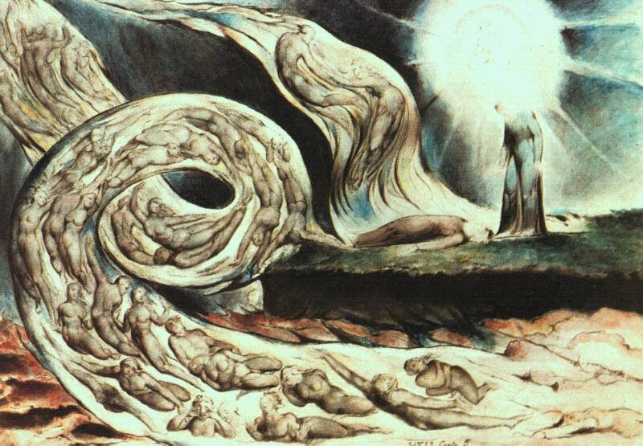

CULTURAL APPROPRIATION:

A Few Points for Discussion

All culture is plagiarism

Within radical circles these days, there is much talk about “cultural appropriation”. Unfortunately, much of this discussion takes the form of moral debates about whether it’s okay for those of European heritage to wear dreadlocks, perform hip-hop, etc. This is just another example of political correctitude calling us to further renunciations. Rather than continuing these rounds of self-flagellation, I think that it is much more useful to examine the nature of culture and how it has been affected by capital and to consider possible directions for an anarchist response.
First of all, healthy, living cultures are not objects, set in stone once and for all, defined and confined within the prison of national or ethnic borders. Rather, cultures are relationships, not only among the people of the culture, but also with other cultures and people. This means that living cultures are fluid, perpetually changing, taking in and giving out new forms and method of being, becoming and creating. Cultural life depends upon this ongoing process of mutual appropriation. Without it any culture will die, and this is what transforms it into an object.
Capitalism has no culture of its own, precisely because culture requires fluidity and living relationships. When capital appropriates cultures, it destroys them as living entities because it can offer nothing living in return (nor is it interested in doing so). In fact, it interacts with the cultures it encounters in the same way as it interacts with every individual life within capitalist society: it reifies, commodifies, fragments, atomizes and homogenizes them. Let’s look at this process. Say, for example, that capital encounters the cultures of Morocco. Immediately an assessment of the potentials of production for profit must be made. So an abstract concept of Moroccan culture must be outlined – Moroccan music, Moroccan art, Moroccan fashion, and so on must be defined. The culture must be separated from the entire cultural flow of northern Africa, the Mediterranean, Arabic, Berber and Tuareg migrations and interactions, etc. This fragmentation allows the culture to be reified, made into a set thing rather than a flow of relationships. It also makes it possible for capital to further fragment the culture itself, separating music, for example, from its daily life context. With this separation comes commodification: the music is put on a CD and offered for sale around the world. And here we see the kind of homogenization capitalism imposes. Every kind of music now appears on identical little shiny discs in nearly identical plastic packaging with a price tag. It has all become a product for sale. This transformation of all culture into products for sale reinforces atomization because it is no longer necessary for us to come together and relate in order to create what we love and desire. Instead we can simply buy its reified form at the shop, limiting our human interactions to the exchange of money for goods. Those who make the music become laborers producing a cultural commodity, selling their creativity where it is not simply stolen.
Since capital turns culture into a dead thing through this process, it can only appropriate cultural artifacts. It simply drains the culture of life in order to attain these saleable artifacts. The reaction of those whose cultures are appropriated by capital is generally defensive. The people of a culture experiencing this capitalist invasion try to entrench their culture against this intrusion. Unfortunately, this reaction plays right into the capitalist process. Entrenching a culture, making it into a thing to defend removes it from the interactive flow of its living history and kills it as an ongoing, borderless relationship. Instead it becomes a kind of sacred property to be protected and kept pure. This separates particular cultures from the surrounding cultures with which they have had relationships of mutual appropriation, thus causing the fragmentation capital needs. It also turns the culture into a thing in itself that is separate from the daily lives of those who live within it. Thus, this very process of attempting to defend cultures against capital transforms them into what all cultures become within capital, a finished product. And this finished product is not really significantly different from any other reified culture since the real, vital differences between cultures spring from their living relationships, the flows of mutual appropriation in which they were involved. Once a culture has become reified, whether by capital or in its attempt to defend itself against capital, the next logical step is the selling of its cultural artifacts.
The failure of these attempts to defend cultures against capitalist appropriation lie in the fact that defense of cultures requires their transformation into a kind of sacred property. But property is only sacred to those who recognize that sacredness. So for this defense to work, the people seeking to defend their culture must demand recognition from the ruling order. In other words, they must demand their rights. The problem is that rights and recognition are defined by those who grant them, and in this case that means the ruling order of capital. And when capital recognizes the right to sacred property, it means the right to sell a product on the market . Thus, it is quite willing to grant this right, since in doing so, it wins.
In light of all this, discussions over Euro-Americans wearing dreadlocks or doing hip-hop are thoroughly irrelevant. Taken to its logical conclusion, this sort of moralizing could end up condemning international travel or learning other languages. It is obvious how absurd and ass-backwards such reasoning is.
The real problem lies with the entire social order of capital and the state which requires the transformation of living human relations into predetermined roles and products from which profit can be drawn. I have already shown how a defensive stance only ends up reinforcing this process. This indicates that it is necessary instead to attack this process of reification, fragmentation, commodification and atomization. And in order to develop this project of attack, the exploited and the dispossessed need to discover ways to interweave their struggles against the ruling order, to find the points of complicity, affinity and solidarity. In this way, what was really living in culture can be rediscovered in the midst of our battle against this society and form the basis for creating new fluid and dynamic relationships capable of realizing our desires and needs in an integrated manner free from the impositions of the economy and the state. Confronting the ruling order in this way may not save what has been, but it will open up new possibilities for life against the way of death imposed by the ruling order.

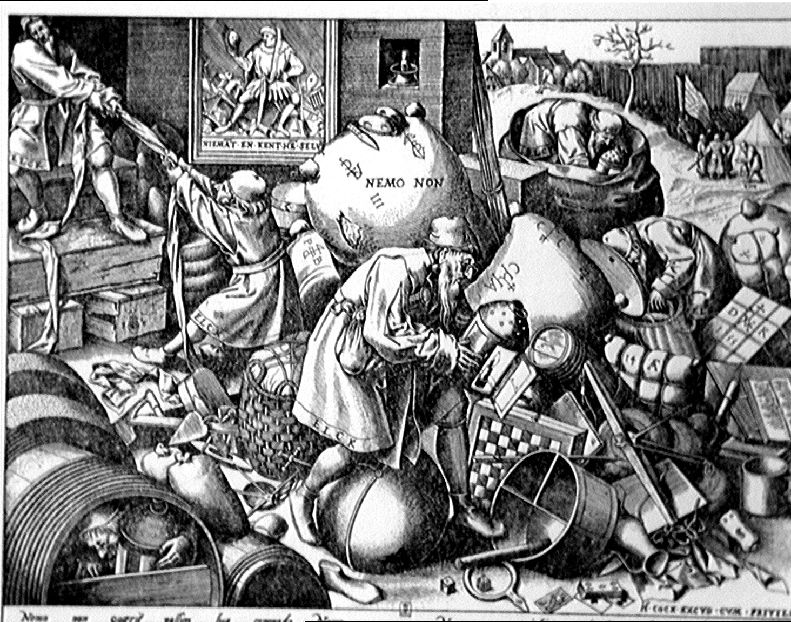

From This Side of the Barricades

Genoa, July 2001: A social uprising invades the city. An uprising slandered by petty politicians and sold by journalists, attacked by police charges and smothered by the chattering of specialists.
Genoa, March 2004: The trial opens – the one that paves the way for others – against the twenty-six demonstrators accused of “devastation and looting” for the rebellion against the G8. The state that threw off its mask during the summit, beating and killing in the streets, torturing in the enclosures of its barracks and prisons, now presents the bill. Meanwhile, the disgusting division into good and bad carried out in the streets by those who wanted to send the former into parliament or onto TV, and the latter to the police station and into jail, is used by these same aspiring leaders of the opposition before the judges in the name of Truth and Justice.
As if there could by one truth and justice in common on opposing sides of the barricades. The truth of the insurgents is that this uprising involved thousands of individuals willing to overthrow the order of money and police clubs. The justice of the state is that the torturers, thugs and murderers in uniform have been promoted as usual.
The investigators divide up history and events in the same way that the machinery of control divides up neighborhoods and cities. A generalize revolt must have its scapegoats, the few to punish so that the many will learn. So then, what will these many do? What will we do?
Let’s not leave the accused in the hands of the judges. Let’s not reduce the insubordination of that July, the contagious solidarity that conquered the streets, to affairs of courts and lawyers, legal codes and pleas. Let’s not let the blood spilt by the state’s cops dry in our minds. Let’s not forget those who fought with courage, those who committed the passionate crime of freedom.
May the generous turn a special thought toward those who instigated the repression by demanding money from the accused and revenge from the judges: the Carige and San Paolo Imi banks, the military police Filippo Cavataio, the Presidency of the Council, the ministries of the Interior, of Defense and of Justice.
From this side of the barricades, we spit on the laws that sanction the domination of human being over human being. If the innocent deserve our solidarity, the guilt deserve it even more.

SOLIDARITY WITH THOSE ON TRIAL IN GENOA

A few accomplices
(Editor’s note: The trial of the 26 people accused of “devastation and looting” in Genoa is still in its preliminary stages. It is up to us to determine how to express active solidarity with those who do not play the rulers’ game of separating “good” and “bad”, and who do not distance themselves from the realty of the violent revolt that occurred there as part of our own revolt here and now.)

CHRONICLES OF REVOLT

Woorabinda, Australia (March 7, 2004)—About 20 young people in this small Aboriginal town attacked the police station with rocks, trapping the two cops inside. Cops from nearby towns were called in to disperse the group.
Myitkyina, Burma (March 11, 2004)—After a drunken cop attacked and arrested two students, other students from the university marched to the police station and attacked it, tearing down signs, throwing stones at the building and setting fire to a number of buildings in the area.
Idaho Falls, Idaho (March 26, 2004)—Someone tore down a power pole using a chain or rope and a pickup truck, also damaging electrical lines and equipment and some radio station equipment as well.
Benton Harbor, Michigan (March 28, 2004)—A small riot broke out when riot cops intervened in an apparent fight between two women. As more cops showed up, more people appeared on the streets. Riot cops formed a line across the street, and people began to throw rocks and bottles at them. The incident occurred near to where cops killed a black man last year provoking a riot. Since then the city council and police have placed a ban on gatherings at this location.
Tuscaloosa, Alabama (Early April 2004)—About two thirds of the school system’s 77 buses were damaged during spring break. Windows were smashed, fire extinguishers set off inside the buses, and CB radios and surveillance cameras ripped out. Unfortunately, two boys, aged 11 and 13, were arrested and charged with 52 counts each of unlawfully breaking and entering a vehicle.
Adelaide, Australia (April 10, 2004)—The Happy Valley primary school was set on fire, causing $1,000,000 in damages.
Skiathos, Greece (April 13, 2004)—Residents blocked the port with fishing boats to oppose the installation of electrical pylons on the island by the Public Power Corporation. They say the pylons are a threat to their health and to the environment.
Edmonton, Alberta, Canada (April 14, 2004)—The 13th incident in as many months of attacks on police mobile radar trucks occurred. A hunk of cement was thrown on the truck from an overpass. Newspaper boxes have been used in some past incidents. In addition, 400 mounted speed cameras have been attacked .
Mangakino, New Zealand (April 18, 2004)—The headstone of the grave of a dead cop was smashed. It had been vandalized with blue spray paint, as was the police station in January.
Monroe County, New Jersey (April 19, 2004)—Unknowns let the air out of 32 school buses and vans, breaking the seals on some of the tires. This gave 4000 students a pleasant day off.
Cincinnati, Ohio (May3, 2004)—Hundreds of people surrounded cops after a traffic stop, accusing them of killing the driver. Cops claim that he killed himself. Several shots were fired at the police, a news van was set on fire and a FOX news car had its windows smashed.
Hwaseong, South Korea (May9, 2004)—Twenty-one undocumented immigrants escaped from a detention center by scaling the walls. Four were recaptured. The guards say they were overpowered when they opened the door to a cell. They say two guards were beaten and the detainees used wrenches to break the locks at the entrance of the building.
St. Petersburg, Florida (May 12, 2004)—Rioting broke out over the shooting of a black teenager by cops and the ongoing trial regarding the 1996 police murder of another black teen. There was looting, battles with police and attacks on businesses and vehicles. The police put down the rebellion the next day.
Buenos Aires, Argentina (May 12, 2004)—Unemployed rebels firebombed the Repsol oil company during a mobilization of road blockades.
Lebanon (Late May 2004)—A general strike against high gasoline prices called by unions escaped their control and turned into open revolt. There were clashes with the police and military, blockades of major highways and looting. The Ministry of Labor building was set on fire. At least three (some reports go as high as six) people were killed by the guard dogs of authority.
Valchiavenna, Italy (May 30, 2004)—An electric tower of ENEL, the Italian electric company was blown up.



INSURRECTION CONTINUES IN ALGERIA

Despite the intense repression at the end of 2002 when hundreds of insurgents were imprisoned, and despite the government and media lies which try to paint it as an ethnic Berber fight for “regional autonomy” and “cultural recognition”, the uprising in Algeria continues. This insurrection, which began after police killed a high school boy in April 2001, has now entered its fourth year. Though centered in Kabylia, insurgent activity is not limited to this region. The strength of the insurgence in this region is due largely to the fact that it has been able to revive and use old tribal methods of horizontal communication, the village and neighborhood assemblies known as the aarch to organize and coordinate activity without leaders.
Since the beginning of this year, there has been much activity. The aarch coordination called for another election boycott – the third since the insurrection began. Demonstrations and general strikes occurred throughout Kabylia and elsewhere in preparation for the event, often involving battles with the police and attacks on government buildings. Algerian president Bouteflika’s attempts to make campaign appearances in various towns in Kabylia were met with rioting, cries such as “Government is the assassin!”, street battles against the police and attacks on government buildings. In addition, there has been much action in protest of unemployment, poverty, poor housing and the like. In this protests, streets have been blockaded, police attacked, government buildings burned, vandalized and shut down, government officials told to get out. I find this last action particularly interesting. Rather than demanding jobs or better housing from the government, people have realized that it cannot be relied on and they demand that it gets out of their lives. This has happened over and over again in various towns and villages throughout Algeria.
The insurgents carried out their boycott of the election on April 8 with a general strike in Tizi-Ouzo. There were also road blockades, attacks on polling places, the destruction of ballots and ballot boxes and battles against the police. According to Algerian government sources, there was only 14% participation in the election in Kabylia and this figure may be high.
Since then the activity of the insurgents has continued with more general strikes, road blockades, demonstrations and attacks on government buildings and officials, often ending up with the closing down of the buildings and the demand that the government officials leave.
The Algerian government tries to keep the insurgence isolated by attributing Berber ethnic goals to it. But the insurgents have made it quite clear that their goals are the end of police and military power and of the hogra, a term for the outrages of the rich and powerful against the poor, matters of concern to Algerians throughout the country. They have also made it clear that they want the insurgence to spread. And if it is not to become another isolated incident, a tragic tale of heroic courage, it must spread, not just to the rest of Algeria, but to us as well. The only act of real solidarity is to carry out our own revolt against the ruling order, where we are here and now.

Dialogue between dream
and memory

The traveler who found herself visiting Kabylia, in northwest Algeria in the past few years, would certainly be surprised at the deteriorated condition of the police stations. The things standing out on the horizon are only the deserted and looted remains of the sinister buildings that once inspired so much fear in the locals. Indeed, because the police have had to abandon their posts in the region driven out and stoned by the insurgent population.
In the spring of 2001, the killing of a student – which happened precisely in one of those stations – made the rage of the population, which was scarred by the worsening of the economic situation and the arrogance of the military masters of the country, explode. The movement born from these events has involved all the inhabitants of the region and is organized in a horizontal manner in village assemblies in which decisions are made through unanimity. Without leaders and autonomous from parties, this movement has been able to keep the forces of the state in check for two years, chasing the police out of the territory, sabotaging elections, attacking the offices of administrative and judiciary power.
In every corner of the planet, insurrectional flare-ups follow one after the other but always seem fated to burn out much too quickly. What is surprising about the Kabyle insurrection, however, is its duration. So let’s try to take a look at the totality of circumstances that have allowed them to resist for so long.
At the time of the uprising, life in the villages was not yet conquered in all of its aspects by capitalist modernity nor completely demolished by past state socialism. The habit of autonomy and the mastery of the techniques of subsistence has survived, and with this the meaning of concrete dialogue among the inhabitants – since they still have the tools for acting well in hand and the capacity for using them, it is easier to discuss what they want to obtain and how. Relationships of mutual solidarity and common pride are still alive, together with a collective memory that carries within itself the marks of an age-old tradition of resistance to every invader.
Thus, the revolt has been able to avail itself of concrete spaces of direct dialogue and self-organization, broadening the networks and social relationships of the life of the villages. At the same time it has occupied an ideal space, fishing out from history the ancient organizational model of the tribes – the aarch – that reached its peak in the struggle against the French occupiers in 1871. Uniting these two levels that were already present in their reality, even if in a disconnected way, these rebels have found what every revolt must be able to build very quickly if it is to survive and strengthen itself – and what more and more often must be invented from nothing.
It is noted that every insurrectional rupture is an opportunity for learning something, the opening of a space in which to experiment with freedom and get to know its enemies. The Kabyle uprising of 2001 exploded at the end of a twenty-year journey through innumerable risings, in which the history of Algeria has been the history of the struggle of the Algerians against the hogra – a term that is always used to indicate the arrogance and abuse of the rich over the poor, of the powerful over the population. A twenty-year period in which the rebels, uprising after uprising, have learned to call governments by their right name, murderers. A twenty-year period in which Algerians have been able to directly examine the morality of the Islamic fundamentalists, so much so as to be horrified by it. A twenty-year period in which parties, which seek to profit from the rage of the exploited in order to cut themselves a slice of power, have been exposed for what they are, traitors.
In short, a twenty-year period in which the insurgents have been forced to rediscover the necessity of acting for themselves, in which the problem of self-organization has been posed by the reality of the struggle itself.
Quale Guerra

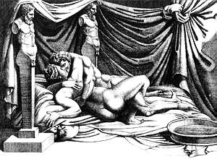

BABYLON’S BURNING!

[It is hard to know what precisely is happening in Iraq. From the many sources of information a confusing picture comes. Islamic clerics certainly seem to play a major role in some of the resistance, and nationalist and ethnic elements are most likely involved as well. But the decentralization of the resistance, and some of the forms it has taken, would indicate that it can’t be simplistically reduced to these aspects.]

Already in March 1991, at the end of the first war against Iraq, the American military collaborated with Saddam Hussein to smother the impressive insurrection, organized in councils, that threatened to ignite the entire Middle East. There were hundreds of thousands of deaths.
Today, with Saddam Hussein out of the way, the troops of the Western coalition, despicable mercenaries in the pay of governments and businesses, are directly repressing the new social conflagration in blood, shooting on crowds of insurgents and slaughtering anyone who talks of wanting to be free.
Today, like then, on the battlefield and in propaganda, the attempt is made to divide the insurgents and defuse the social significance of their struggles, enclosing them in ethnic, religious or nationalist conflicts. In Iraq as everywhere, in the face of an open class revolt, the state prefers to prepare a fratricidal war of all against all. The slaughter of March 11 [in Spain], striking the exploited in mass instead of their governors, only attempted to return the blaze of terror to the West.

In this abyss of war, hunger, pandemic disease and desperation, the threatening flames of proletarian rebellion are leaping up more often. From Argentina to Algeria to the Far East, they split the capitalist order. The exhaustion of these revolts, their suffocation in nationalist, fundamentalist or ethnic drifts depends only on their isolation.
Attacking the state and property, insurgents everywhere speak to us. It is just up to us to respond, bringing their attack here into the big cities of the West, where the conditions of life are crushed more and more every day between precariousness and fear and where social life is militarized as if in an internal front that does not allow desertion.
Because it is here, where the beating heart of the Economy and its armed hands reside, that the capitalist order can be smashed, when the flames ignited by the exploited of the planet set fire to the minds of their class brothers and sisters in the West.
“Porfido” Center of Documentation, Torino, Italy
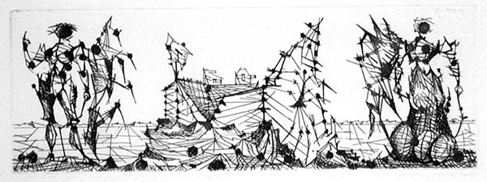

TOWARDS SOMETHING NEW

The long road of civilization, which has led to the present-day technological-spectacular society, has been a continuous process of separation from nature and of domestication of individuality. Now more than ever, this is evident in the capitalist desire to free commodity production from the earth and its resources, as well as in the city dweller afraid of losing her grip on society. It is evident in destructive processes, and in those tending toward the concentration of people into a homogenous mass. It is also evident in the alienation from our own bodies and in the entrusting of their cure to specialists accustomed to treating one body after another without valuing subjectivities at all, almost as if these bodies were machines.
And this process has really operated mainly on this last aspect, not only separating us from external nature, but also from the form of nature, unacknowledged and mistreated by most, that we are. In this way, domination plants its roots in the brains of individuals convinced, or maybe constrained, to consider themselves other than nature. But we are not allowed to clearly know what this other is. And by steering the middle course between the pedestal of domination over nature and the simultaneous evaluation of being insignificant within the social Moloch, it is possible to make the appeal to work in order to impose new ideals of the human being, absolutely functional to technological domination and truly other than nature. It becomes imperative to integrate oneself, to evolve at a pace equal to the technosphere’s separation from nature . And methods for integrating oneself are not at all lacking within the ruling order. They are not merely ideological: genetic manipulation already finds applications on the human being, and individuals are already designed in the laboratory, thus carrying evolutionary control to its farthest end. What genetics cannot achieve, especially on the social plane (truthfully, a lot), will be achieved thanks to nanotechnology that already allows the implanting of micro-chips under the skin with infinite possibilities, from location, to the control of gestures and actions, up to interaction with the biological system. Today the lines of control tend to flow more and more into the fabric of life.
F.C., the so-called Unabomber, observed in the manifesto, Industrial Society and Its Future: “In the future, social systems will not be adjusted to suit the needs of human beings. Instead human beings will be adjusted to suit the needs of the system.” (thesis 151) With one small error, that this future is already present. And it has always existed, even if in less intrusive terms, with the adaptation and chaining of individuals to economic development: work, the factory, degradation of food, commodification, spectacularization, etc.
Going back in time we can see how Descartes smoothed out the path for such artificialization with his mind-body dualism. Setting aside the mind and shifting attention to the body, objectively quantifiable and controllable, he pointed the way out to science, which has today achieved transplants and the artificial creation of organs. Already Descartes himself asked, “Couldn’t living organs perhaps be conceived in a satisfactory manner, and thus governed, as if they were machines?” But science has gone further, not only realizing his idea as the basis of modern biology, but then conceiving organisms fused with and ruled by machines.
The creation of a post-human race and the colonization of the cosmos by machines, as proposed by the scientistic extropian cult, are no longer only subjects for films or the isolated delirium of some fanatic, but projects under study in the universities of robotics and in research center scattered throughout the world. The extropian Hans Moravec admits his fantasy that “our non-organic descendants, lacking our limits, capable of redesigning themselves, could follow the awareness of things, confining the already surpassed humanity in an edenic environment, like a park.” But more likely, in the name of efficiency, and in view of the objective difficulty of finding an edenic environment on this ravaged earth, the descendents of Moraves would eliminate the obsolete organic human forms. The machine and artificial intelligence are now considered by many as the next level of evolution. The disquieting vision of cyborg Kevin Warwick, who has inserted a chip∗ into his arm that commands lights, entrances and computers in his office, is that fifty years from now machines will manage humans and artificial intelligence will outclass and eliminate human intelligence through the physical intervention of psychosurgery.
Beyond the obvious excess of fanaticism that certain theories reach, there is still a very precise direction: the elimination of the living being as we have known it up to now. What comes about with genetic engineering, controlled sterilization and reproduction, the creation of cyborgs, the cognitive flattening to the level of machines or the purging of the unsuitable is to be seen, but certainly this technological ideology will damage us from now on, whether there is a concrete realization or not. We are already at a point where reality and simulation sometimes become indistinguishable, and in an extension of the techniques of spectacular representation, there is now talk of artificial senses capable of making our perception of reality completely virtual, mediated and thus impoverished.
Before it’s too late, let’s realize that science and technology are historical phenomena directed by a vulnerable elite and that our enslavement is in their interest. The key to the ascendancy of machines and of the post-human for an even more totalitarian domination lies in our acceptance, like it does for every form of exploitation and control. And it is only by overturning this notion and the current society, that it will be possible to find the key for the unknown world of freedom.

Terra Selvaggia

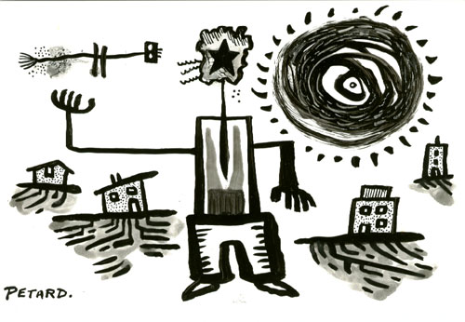
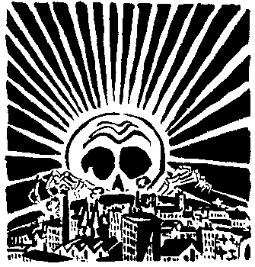

THE MYTH OF PROGRESS
And the Problem of Civilization(s)

Since the enlightenment, the Western ruling order, which now rules throughout the world, has justified itself mainly in the name of Progress∗. But Progress is a myth, an overarching ideology by which modern western civilization has tried to uphold its values. In other words, Progress is the way through which the social order of capitalism, industrialism and the state throws its own values back across the totality of human history interpreting everything on its terms.
The myth of Progress has some significant implications. First of all, it implies that the present social reality is the best that has ever been, that all that ever was has been leading to this and that future improvement lies along the same path. From this, it follows that what was and what currently appears to remain as what was (so called primitive and peasant cultures) are inferior to what is currently the most “advanced” human condition. This all further implies that there is one single path for humanity to follow and thus that only one civilization has developed. And finally, it implies that there is a single great end toward which history aims.
Before going into the blatant fallacies of this myth revealed in these implications, it is necessary to point out that this myth rose together with the development of the Western scientistic- technological ideology and practice of the modern era. Thus, human Progress is interpreted as scientific and technological Progress. Advancement is understood as the advancement of techniques and of the level of human dependence upon them combined with the quantity of facts compiled and stored by the society as a whole, which is then defined as human knowledge. From this perspective, the end toward which history aims is human domination over nature – an idea that requires the civilized perception of a unified nature that stands in mute opposition to human culture.
At this point the myth of Progress stands in tatters (but it still stands) because the technology it upholds has so clearly gone out of control and some of the science it upholds has undermined a number of its own assumptions. At this point, the endless parade of wars, disasters, epidemics and increasing misery makes the idea of this social order as the best that ever was, the highest human achievement, a sad joke. And the idea of continuing along the same path is absurd, particularly when the scientists and technicians themselves tell us that this way is leading to disasters on a scale far beyond the horrors we have yet seen, from water wars to possible ice ages, and at the same time, speak of the new technologies that may even make the human organism “obsolete” – if one accepts the myth of Progress. It is obvious that a human existence worth pursuing lies elsewhere.
Furthermore, science itself has undermined any conception of a single path, a single civilization developing toward an ultimate goal. The fact that modern western civilization – capital, the state and their technological system – has come to dominate the globe has allowed it to make the tale of its evolution the official history of the world, so that “Fertile Crescent” is still called “the cradle of civilization”. Yet Chinese, Japanese, Incan, Mayan and Aztec civilizations (to name the best known) have no connection to this “cradle”. Thus, there has not been just one single civilization progressing (either steadily or dialectically), but several different civilizations with different perspectives and different myths through which they upheld their values. Some of these civilizations seem to have used a myth of Stability – even of apparent eternity – rather than one of Progress to uphold their civilizations.
Nor has the development of western civilization at all been a smooth or even a steady dialectical development. Instead, a variety of civilizations had brief developments, and then fell before other newly arising civilizations in a variety of conflicts. The apparent picture of a relatively smooth evolution is the invention of modern western civilization which lays claim to all the written records from Sumeria west-ward as a single path progressing to the present.
In recent decades, some of the ideological proponents of the ruling order have proclaimed the “end of history”. This proclamation may be a necessary response to two realities. First of all, the fact that the myth of Progress is in tatters precisely at the time when a single civilization, capable of recasting history in its own image, dominates the globe. The proclamation of the “end of history” both allows historians to proclaim the domination of this single civilization to be the aim of history and offers a new myth of Stability and Inevitability to replace the myth of Progress. The second thing this proclamation may be trying to confront is the reality of a technological apparatus that is no longer truly under human control. The idea of this apparatus as a tool through which human beings dominate nature can no longer stand up to the reality of the apparatus itself. Thus, the idea of progress as the historical development of humanity toward total domination over nature is absurd since human beings are no longer in control. The proclamation of the “end of history” can declare this juggernaut to be the technological achievement of the true aim of history. And yet, as we look at the results socially, psychologically and environmentally, a history with such an aim seems utterly absurd.
In light of what is now known, those critiques of civilization that consider it as a single entity with a single development need to be rethought. We can certainly see traits that all civilizations have had in common, particularly the various institutions of domination and exploitation – state institutions, economic institutions, social institutions and systems of techniques developed to put and keep people in their place. But trying to trace this all back to a single source may reflect a continuing attachment to the myth of Progress, even if this Progress is viewed negatively. The danger in this lies in developing an almost christian view of history. This single source takes on the role of original sin leading to an inevitable fall. The “end of history” becomes an apocalypse, which may lead to redemption. In any case, just like the positive version of the myth of Progress, this negative version implies a kind of determinism that takes the capacity for making or destroying history out of our hands.
In fact, we know that many civilizations have arisen at various times. Most have either been short-lived and collapsed. Some have quickly settled into a relatively static form and carried on in that form for ages. All of them have existed as a network of institutions of domination and exploitation into which people were to be fit. For this reason, I think it makes sense to define civilization as a network of such institutions. But modern western civilization was able to come to dominate the globe because of specific historical conditions that came together in Europe about five to six hundred years ago. The gradual conquest of the globe that followed was justified with the myth of Progress, but the reality has been an ongoing degradation of humanity and the rest of the living world.
The dream of going backwards still buys into the myth of Progress, even though in the negative sense. It still implies a single path along which humanity has traveled. It is the reversal of history rather than either its rejection or its reappropriation. As I see it the progressive conception of history – the ideological justification of the present order of things – has never made sense from the standpoint of our freedom as individuals to create our lives together as we see fit. It has always placed a “higher value” above us, a great ideal which we are to serve. History in this sense needs to be rejected by those of us who want to create our lives on our own terms. But there is another way of conceiving history that can turn it against civilization and the myth of Progress. It is the conception of history as the game we play when we place our lives at stake against this world in the individual and collective creation of freedom here and now in open revolt against the juggernaut that dominates and threatens our lives, wagering that the world can be radically transformed, that destroying a world of domination can take us elsewhere. Having ceased to be puppets, let’s play!


“Giving battle”

Our five sense do not belong to us. Only one thing belongs to us, desire. We would like to live on our own behalf, throwing a glance on the world in order to seek out an activity of our own, fruit of the necessities and dreams that animate us and not timed by the rhythms of others.
In order to start doing this, we would need to avoid, as much as possible, moving in the way we are pushed by the conditioned reflex provoked by the hammer of repression. It’s a matter of escaping from the vicious circle into which they would like to lock us, distancing us from the social conflict and pushing us into a private competition between us and them.
If we intend to protest effectively against an arrest, why don’t we poke a finger in the thousands of electronic eyes which surround us, as was done recently in Milan? Doing so doesn’t necessitate concentration at a single point – thus, it avoids running up against possible disciplinary provisions like expulsion papers or warning of other kinds – ; it concretely disturbs social control, is an act the reasons of which relate to all and is therefore easily comprehensible to anyone, making it more difficult for it to be attributed to “those who have a bone to pick with the police because they arrested their friend.”
With its repressive operations, the ruling order shows us in negative what they really fear: not so much the current position conquered by its enemies, in itself insignificant, as the further attacks that this would allow. Come on, let’s set aside panic and victimistic complaining. In a society in decomposition, it is certainly easy to remain buried under the flood of its rubble, but it is equally true that its possible points of rupture multiply. It is thus a question of looking for them and trying to break them down. The discomfort against this world without meaning is mounting; it is no longer a discussion made by and for a few subversives in the enclosure of their spaces, but it is becoming a common feeling capable of transforming itself into action and blocking state projects in course.
In the course of a few weeks, an entire region has mobilized itself, a wildcat strike has paralyzed some cities, the fire brigades have taken to the streets because they refuse to be militarized… and it is a list that could be lengthened at any moment. We are not yet at grips with a fire, it is true, but it is still a matter of live embers on which it is possible to blow. Just as it is possible to blow on other, apparently inert embers that the breath of revolt may be enough to ignite. Looking around in order to distinguish the places of malcontent and there incite the minds. Intervening in every conflict in order to sabotage pacifying negotiations. Arousing social hatred where fatal tolerance is in force. Ceasing to tail power – political, economic or judiciary as it may be – like a shadow faithfully following its dates and priorities, abandoning the space in front of the palaces of power and the court buildings in order to move everywhere.
Perhaps what is still missing is the attempt to link the struggles that are going on, to create bridges that allow all those who are protesting to meet and recognize each other. Because the reasons that pushed the inhabitants of Scanzano Jonica to block the roads of Basilicata are not really different from the reasons of the transit workers who blocked traffic in Milan. The former, like the latter, are treated as mutes presented in a representation written by others to the benefit of the usual few. But aren’t we all victims of the same lethal muteness? And on the other hand – if we want to start speaking and raising our voice – we must take into account that the language of revolt and suffering cannot resemble that of power and privilege. When one becomes aware of this, only then does one comprehend that there is no dialogue, no understanding, no agreement possible with the other side. Then one throws out the political and union ballast and begins to intervene autonomously in the social stir, supporting, without any shopkeeper’s interest, anyone who is no longer willing to submit, pursuing the possibilities that open before us, all to be discovered.
Quale Guerra



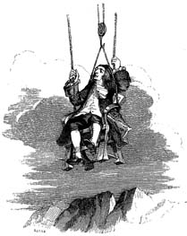

Helping out WD

Donations of cash or stamps are always useful. Sample issues are available in North America for $2 each ($3 for double issues) and subscriptions for $5 for 4 issues. Overseas, sample issues are available for $3, subscriptions for $10 for 4 issues. Send cash, usable US postage stamps, checks or money orders to:

Venomous Butterfly Publications
818 SW 3rd Ave., PMB 1237
Portland, OR 97204
USA
e-mail: acraticus@yahoo.com

 Apparently, he now has several implanted chips…
 I have capitalized “Progress” throughout this article to clarify that I am speaking about it as an alleged historical force and a great ideal above us, not as the steps toward accomplishing a particular task or as real improvement of a particular situation.

