THOUGHTS ABOUT
COMMUNITY
SUPPORT
AROUND

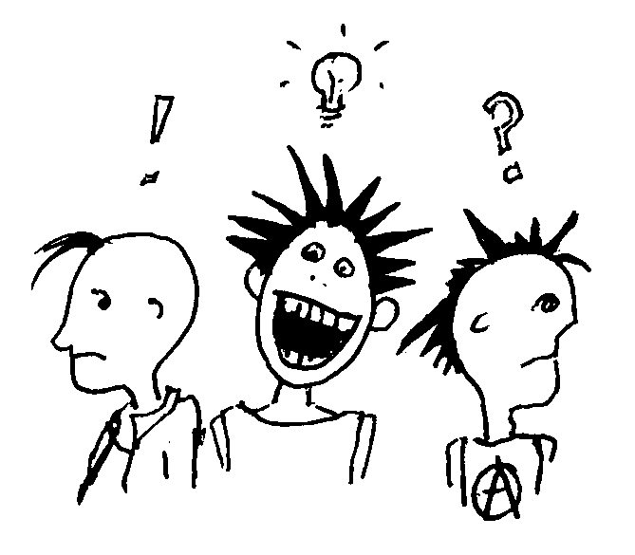

INTIMATE VIOLENCE

It becomes safer for all of us when we recognize men’s violence is a community problem and support each other in dealing with it.

Exercise 16
Getting Help for Others

- Do you know of any situations in your family or among your friends in which a man is beating, controlling, molesting or otherwise hurting someone else?
- What is dangerous about this situation for the people involved?
- How might it be dangerous for you to intervene?
- Besides the danger, what reasons have you used for not getting more involved?
- How could you caringly confront the person who is abusive?
- What kind of support can you give the person being abused?
- Who can you talk with to get support for intervening more strongly?
- Do you know any men who have a problem with violence and refuse to get help?
- How can you be a friend to them and support their stopping the violence?
- What are three things you could do if you see a man hit a woman in public or a group of people attack another person?
- Why would doing these things be scary or dangerous for you?
- Why is it important for you to intervene?
- How will you feel about yourself if you don’t do anything?
- What are some things you could say when you see a parent abusing his or her child?
- What are some ways to interrupt harassment of women, gays, lesbians, bisexual people, or people of different ethnic groups?
- What do you gain if our communities are safer for women?

42

This zine was inspired by a group process. It is in no way is a substitute for the process that we went through and we firmly believe that everyone should be starting small groups of their own, discussing this topic and generating your own zines. We would love to read them.

The process we went through: as a group with five people of varying genders we took on the following topics, one per week, in meetings of about two hours.
- definitions: what is abuse? what is domestic violence?
- definitions: is there such a thing as consensual violence?
- how do sexism and homophobia relate to intimate violence in both het and queer relationships?
- how does US dominant culture affect domestic violence (in the US)? what roles do the histories of racism and immigration play?
- what are the issues involved in a community response to intimate violence? what is accountability?
- what does good support for all parties involved in intimate violence look like?

We weren’t trying to come up with definitive answers to anything, just to explore the ideas and learn from our various histories with the topic. Some of us had history in non-profit social work and all of us had dealt with conflicts in our political communities (we are the type of people who get called when someone has a problem). Most of us had experienced intimate violence in our personal lives, both as kids and as adults. None of us had ever been publicly accused of abusing someone, but we all had friends who had been accused of this.

A couple of us had been in other groups around this issue that had fallen apart, at least partly because the topic is so damn intense. So we made the questions theoretical because we thought it was important that nobody got personal before they felt ready. By the end of the group everyone had discussed personal experiences and felt safe doing it. We agreed that giving ourselves enough time to really consider what we thought, and trusting each other to work through controversial questions, was an essential part of getting somewhere different in these conversations. We also thought it was important that we did this with people we knew and trusted. Many of us had been part of large conversations and presentations in which people didn’t know each other well or at all, and these conversations never seemed to go very far. People could neither learn nor share as deeply as needed, since there were few (if any) deep personal connections or commitments. So we wanted to keep our group small. If other people wanted to talk about the issue we encouraged them to have their own small, trusted groups.

The process of this group has been inspiring in a way that a lifetime of political work has seldom been. Doing work that is concrete and theoretical and emotional rocks my world. And at the risk of sounding sappy, this group is amazing − smart and dedicated and brave. Reading this zine can not reproduce this group process. The value of this work is the community connections created through talking with yer buddies.

You can e-mail zines or constructive criticism to jamiesays@earthlink.net

a page for writing down important ideas

We need to:
-acknowledge, understand, and at least partially heal from our own past experiences of violence;
-feel confident enough to make ourselves be vulnerable to another man’s violence;
-acknowledge our fear of further violence;
-acknowledge and understand our own gender-based training to be violent;
-recognize our anger at his violence−that anger can keep us from colluding with him.

Nearly everyone in this society has been bullied and been the object of violence. Nearly everyone has bullied someone else. Acknowledge this commonality of experience with a violent man and use it to talk with him effectively.

Alternatives and Resources

We know that a violent man needs to:
-know change is possible and that he does have alternatives;
-know specifically what those alternatives are and where to find out about them−how to start the process and what community resources are available;
-learn other ways to deal with anger;
-learn how to express other emotions, including pain, hurt, sadness and frustration;
-learn to get his needs met and to resolve conflicts without resorting to hitting, intimidation or abuse;
-get help in examining his gender training;
-get help in more deeply understanding his personal and family history;
-be shown the resources for dealing with other issues such as drug abuse, health problems and unemployment;
-know that we expect him to use these resources to eliminate his violence.

We don’t have to be crusaders or self-righteous missionaries. We can make our presence felt by intervening in safe ways and completely respecting the people involved.

41
We can provide him with this information through one-to-one dialogue, group discussion, legal intervention, or public confrontation. Since confrontation is always risky, no one can judge how much someone else should say or do. But we become complicit with the violence if we don’t take some steps to confront it. This can be done by police, friends, neighbors, and other family members. Effective confrontation decreases the level of violence. Our primary responsibility is to stop the immediate violence and to support the people attacked.

Support
Individual men who are violent need our support to make positive changes. Support should not be confused with collusion; the violent situation cannot be allowed to continue. Support must be conditional on the violence stopping.
To support a violent man we must:
-confront his violence;
-separate his violence from his worth as a person;
-help him understand that his violence comes from his hurt, pain and powerlessness;
-help him see that violence is dangerous, self-defeating, and ineffective in getting his needs met;
-make a commitment to caring for him over time, providing a compassionate and empathetic ear to his experiences of violence, hostility, anger and despair;
-recognize his training to be male and his unique place in the power hierarchies of our society, including those based on class, race, sexual orientation and cultural background;
-help him understand that violence is learned and an unnecessary behavior that can be changed;
-address that part of the man that does not want to be violent and does not want to hurt others;
-help him admit he has a problem;
-help him ask for help−perhaps one of the hardest things for a man to do.

Personal Clarity
In order to confront another man’s violence and to support his changing, we must also have some clarity.

40

INTRODUCTION

What is this?

- This zine has suggestions for how to do good support for people who have recently experienced intimate violence, both the survivor and the abuser. We define intimate violence as any kind of ongoing abuse or violence that happens between people who are tight with each other: lovers, friends, housemates, band or commune members, affinity groups, superhero crew, people raising a kid together etc. It includes physical, emotional, sexual, verbal, or psychological violence or any other kind of abuse (there’s a list of some common fucked up behaviors on page 34).

- Included are ideas for how to do both physical and emotional support, as well as support to help folks start to understand what they’ve experienced and take responsibility for their actions. We’re calling this third process transformative support for short. The way the support process is laid out might make it all look pretty simple, but don’t be fooled, it’s not. To give an idea of how complicated things can get, we’ve also included some stories from our lives.

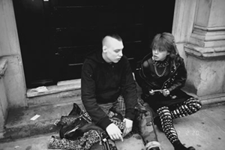

1

Why is this important?

BU
I
L
D
I
NG

A
HEA
L
T
HY

C
OMMUN
I
T
Y

T
AK
E
S
A
L
L
O
F

US

- It might seem weird to write a zine for supporting both the victim and the abuser. So here’s why: we believe in revolution and community and people’s capacity for change. We believe in helping each other figure shit out, that we all fuck up sometimes and we all have the capacity to fuck up majorly, especially having been raised in this sick and twisted environment they call civilization. That the only way stuff is really going to get any different is to call each other on shit and then learn how to do it better the next time around.

- Right now the two most common responses to fucked up behavior are ignoring/denying it, or getting rid of one of the people. We refuse to ignore it! Domestic violence is the leading cause of injury to women: more than muggings, stranger rape, and car accidents combined. In every community, including ours. It’s time to give back our “it’s none of my business” and “there’s nothing I can do about it” blinders. Smashing oppression and building a healthy community takes all of us.
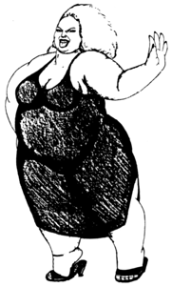

- On the other hand, if kicking people out of a scene is the only way to deal with violence, it creates a dynamic of demonization which doesn’t help the abuser admit to having been a jerk. It also makes people who like them (maybe even the abused party, since they started out tight) less likely to want to talk about the incident(s) in the first place. People who fuck up are often great and wonderful some of the time, and might
2
This is a chapter out of a book about how men can help men stop being violent. Although it was written specifically for one gender, there’s stuff in here that’s useful for other genders too.

Helping Others Get Help

from Men’s Work by Paul Kivel

Getting help for ourselves and seeing why sometimes we don’t get help when we need to can lead us to more effective strategies for intervening with other men who need help. All of us live with and know male friends, family members, co-workers and neighbors. What can we do when one of them is violent?

Intervention is never easy. In a society in which inter-personal violence is taken for granted, it is risky for us to get involved−as if we weren’t already involved, as if we didn’t already lead lives of fear because of the prevailing levels of violence. Next time it could be one of us who needs help.

Family intervention is most delicate. The privacy and sanctity of the family, the feeling that what they do among themselves is their business−all these ideas prevent us from being involved. How much is it “their business” when our neighborhoods are disrupted, [the] medical and legal systems are overloaded, people are killed and lives destroyed daily from the results of family violence?

Nevertheless, when interacting with violent men, we must remember that safety comes first! We must be safe from immediate danger and retaliation before we can ask someone to accept responsibility for his violence or offer support to him.

Confronting a man who is violent means letting him know clearly and directly that the violence is unacceptable and cannot continue. Let him hear that violence is illegal, dangerous, will not be allowed to continue. He may also need help seeing the costs to himself in lowered self-esteem, pain, despair, and the brutalization added to his own life and surroundings.

39

What do positive relationships look like?

yummy relationships are ones where you -
- openly express your feelings, thoughts and desires
- pursue what you really want to do with your life
- share time and experiences and feel companionship
- work together on difficult issues in the relationship
- work out solutions together equitably

Conclusion

You stuck with it this far. Good job. We don’t have any more words of wisdom. We ran out. But we do have lots of encouragement. We know that this is an idealized vision of what could happen around a trauma. So mold it and shape it and mark it with a B (or whatever letter you prefer) and adapt it for whatever kind of community or situation you’re in. And let us know how it goes. We’re open to and would like to get feedback, but we’re not opening a consulting firm. We’re not the experts and don’t want to be. The process is what you make it, we make no claims it will work perfectly. But we know you all rock and your communities can handle this shit. To send us your fabulous ideas on community support, zines or feedback, write to jamiesays@earthlink.net

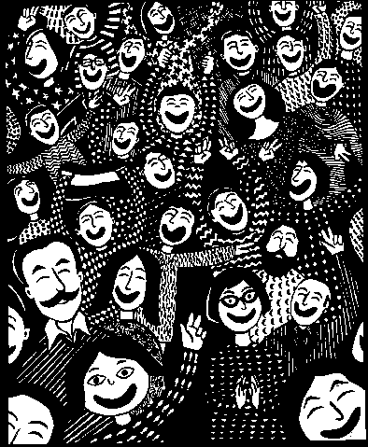

38
be doing important work in the community. If we bought everyone who ever fucked up a one way bus ticket to Nebraska, the scene would get real small real fast. And it wouldn’t be very fun for the folks in Omaha.

- That said, the process is only going to work for folks if they both: a) actually want support and b) are interested in changing themselves and/or their situation. There are lots of creative ways of encouraging people to be more interested in change, ranging from baking them yummy food to threatening them with boots. If they’re really and truly not into it, it’s (and perhaps they’re) not worth your effort. In which case all you need to do for them is stop them from hurting the other person by any means necessary. But don’t give up trying to convince them without a good prolonged struggle (including some time outs for everyone involved), because when you can get them interested in change, hot-damn, it’s a revolutionary process (more suggestions on how to sway a reluctant jerk on page 30).
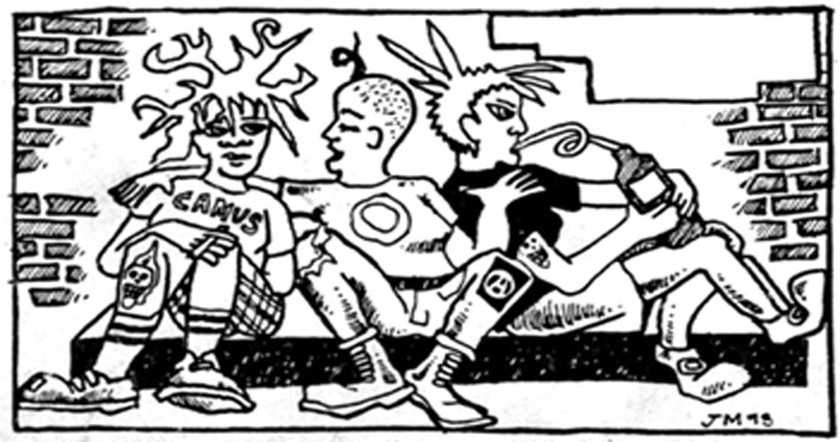

- Plus, creating a model for community support allows for earlier intervention. Helping folks talk through shit when they’re still in the yelling stage just might keep them from getting physical. A lot of violence is about isolation. The fact that this culture’s got its head stuck deep in the sand is part of what allows people to beat each other half to death. We did some reading about domestic violence in cultures around the world, and it really does exist everywhere. But in some places people are not so isolated from one another; there, if your friends and neighbors hear you fighting, they come over to
3
see what’s up. Or the women in the neighborhood come over and stand around your house holding sticks and make the guy take off for a while. And in those places injuries from intimate violence were not severe and death was almost unheard of.

- Unfortunately this society doesn’t come stocked with too many good alternatives for dealing with Intimate Violence. Cops suck. The criminal injustice apparatus, which systematically targets and brutalizes communities of color, radical and queer communities and immigrants, is not the first place many of us think to call when we are under attack. Courts are notorious for letting male abusers off the hook, and simultaneously slamming female survivors for fighting back. Besides, jail never helped anyone (more about the police on page 36). There are some services like shelters and group counseling out there, which can be good as far as they go. But social services tend to be pretty limited in their options and outlooks. Our friends who work at social band-aid institutions are at best overworked and constrained by the legal system. At worst social workers could give a shit, or would think doing community support was wrong and try to sabotage it. So be careful. If you’re thinking about referring someone to an agency, do a little research. Try to find out what the organization’s reputation is, and what it’s actually going to be able to do for someone first.

A few words about words

- In intimate violence, or any conflict, it’s not always super easy to tell who’s the bad guy. Sometimes, as in your classic “wife-beater” scenario, where a man punches and screams at a woman, who is unable to leave him because of money/kids etc., there is clearly one person who is doing 99 or 100% of the fucking up. But it’s not always that clear cut. It could be that one person says mean shit and the other one throws ashtrays (although in general people are good at playing out the roles society has created for them). In any case, English is pretty limited in its terminology, and most of the words that do exist around this stuff have connotations that we’re
PATRIARCHY IS A RAGING MENACE
4

Story # 5
I was involved in supporting a good friend of mine, Dawn, while she was in a rough violent relationship. She was dating another woman, Anna, from the community. They decided to travel together and move to a new town. After they left I got regular calls from Dawn explaining to me how Anna had freaked out on her and beat her up, sometimes giving her black eyes. I talked with Dawn about leaving the relationship but she said she could not because Anna was helping her out with money and stuff. After a few months of that they broke up and moved into separate houses.

Then they started seeing each other again. One night Dawn had a few drinks and went over to Anna’s house. Anna was with another woman. Dawn freaked out and pushed Anna and then began screaming at her. Dawn refused to leave the house and pulled the phone out of the wall when they tried to call the police. Eventually she left. Anna filed a restraining order against her. Dawn was extremely upset about this because of all the times she was hit by Anna. She was also upset because Anna was using the court system even though she was a self declared anarchist. Anna held the restraining order over Dawn’s head, knowing she worked with youth and continued to contact her although Dawn was not legally allowed to contact her back. Eventually Dawn filed a similar restraining order and then they went to court together and decided to drop both of them.

After this they were broken up for awhile. Then they became friends again and began sleeping together. Dawn was not into the idea of actually being together and also was sleeping with someone else. When Anna found out she threatened to kill herself and became really upset.

Now Dawn has moved out of the town they were living in because all of Anna’s friends watch her every move or are rude to her because of what Anna has told them.

This situation was extremely complex with no clear cut “bad guy”. It also had an impact on the community due to both parties talking to their friends about what was happening. The ripple effect of this could actually be felt in a few communities. Both of these women have somewhat similar patterns which will continue to effect the community.

37

Callin’ the Cops

So we all know the cops and their systems are fucked up. One of the main reasons for this zine is to encourage people to come up with community-based solutions to avoid calling them. This may not always work and you might be faced with a situation where cops are your only viable option, since community support systems might not be in place yet, or might not be accessible to you. If your life is in immediate danger call 911. They still might not get there in time, (or do much to help even when they arrive), but their presence can sometimes help to keep you from getting hurt in that moment.
If you have physical evidence of abuse ⬇ could be arrested and sent to jail for a few days whether you want this to happen or not. Or they might not take ⬇ away, even if you want them to. If you press charges, you both will then be involved in the system and have the required court dates and bureaucratic bullshit to deal with. ⬇ might be fined heavily and required to attend anger management classes. If either party or anyone in the household is undocumented, involving the police puts them at risk of deportation. People of color and queer or transgender folks are also always at a higher risk of brutality from the cops or the courts.

Another legal thing people can choose to do is file a restraining order. This does not always stop abusers and the cops won’t be waiting around to protect you.

In the end you are the only one who knows the direct reality of your situation. DO NOT PUT YOUR LIFE AT RISK TO PROTECT ⬇ FROM THE SYSTEM. But don’t expect that system to be supportive of you either.

36
not thrilled with. For example, the word “abuser” tends to demonize, “victim” is disempowering, “survivor” assigns value for suffering, and “accused” questions the validity of the problem. And since we’re not smart enough to come up with our own words, we’ve decided to use symbols instead:  for the survivor/accuser/person who was harmed, and ⬇ for the abuser/accused/one who’s fucking up the most.

- Also, we’re gonna use gender neutral language. ⬇ is male in somewhere around 90% of domestic violence cases (ongoing abuse between partners/lovers). But we also know that domestic violence occurs in 1/4 of all relationships, het, homo or otherwise. Not only is it important for queer folks to be able talk about the violence in their/our relationships, but its important for us to acknowledge that women can also be jerks. We are all capable of a full range of human expression, even the shitty kinds. Patriarchy is a raging menace, and definitely contributes to the existence of violent behavior, but it’s not the only cause of abuse.
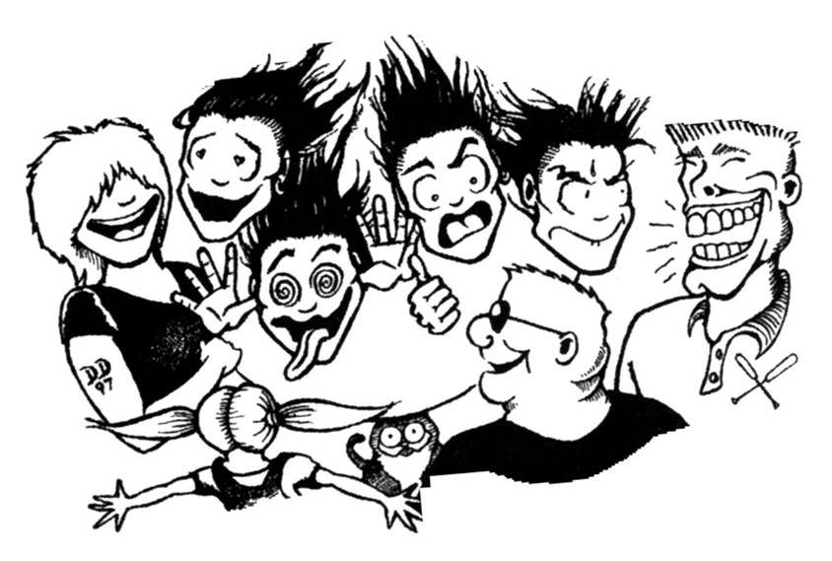
- We like to *#$≠%@&! We wrote this the way we talk, using language that’s accessible to our community, because this issue is a problem in our community. We’re not out to save the rest of the world, at least not before 4:00 this afternoon. But we welcome anyone who wants to translate the zine into other dialects so it can be useful in different communities.
RAGING MENACE
5

When, how and for whom is this useful?

- This zine is targeted at folks who are looking to give support to their friends. But it would also be useful for someone who is interested in getting supported, in order to get ideas for what they might be able to ask for. Especially of they’re isolated. In a lot of abusive situations both parties can lose contact with their friends, or perhaps they’re new in town and that’s part of what made them vulnerable to the abusive situation in the first place. To  and ⬇: If you’re having a hard time and don’t have many folks who you’re close to, don’t be shy – call, email or drop in on an old friend or acquaintance and ask for help. Try to be as clear as you can about what you want from them. Most humans (and many other animals) are pretty into doing good deeds as long as they have a good idea what they’re getting into.

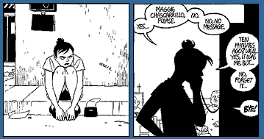

- Not all communities have tons of people standing around just waiting for the opportunity to do support. Probably this zine will work best in larger, or more established communities. That doesn’t mean you can’t take it and adapt it for your situation. If your community has limited support to offer, you might also decide to look for support elsewhere, like domestic violence agencies, the courts, cops etc. (See page 36 for more on calling the cops).

- The support process is going to work best if you look at this stuff and talk about it with your buddies way before a crisis looms in on the horizon. Study groups are great (we love ours) or you can just chew on it for a while with a good friend. Crises are mega-fucking-hard to deal with even when everyone’s prepared and on their
6

Examples

- Shouting, pushing, spitting, shaking, holding you down
- Accompanying you everywhere
- Making decisions for you
- Telling you you’re a failure, crazy, stupid, a slut, no one else cares about you
- Being mean to your kids or pets
- Refusing to practice safe sex
- Criticizing your abilities
- Being super jealous or possessive
- Sending you unwanted gifts
- Throwing stuff or punching the wall
- Mocking or humiliating you
- Playing mind games
- Continually breaking promises
- Criticizing you in front of others
- Telling you you’re irrational
- Ignoring you or withdrawing affection
- Telling you what to wear or criticizing your appearance
- Coercing you into having sex
- Having sex with you when you’re asleep
- Making you prove your love/friendship
- Preventing you from sleeping, working or studying
- Taking your money or making you pay their debts
- Physically preventing you from leaving
- Destroying your possessions
- Isolating you from your friends and family
- Driving dangerously
- Threatening to commit suicide
- Threatening to have you deported
- Harassment after separation
- Making you believe it’s your fault

35
Common fucked up behaviors


Most physical abuse is pretty easy to recognize and define as violence. Other kinds of violence are sneakier. Saying “You’re crazy” can be as damaging as a punch in the face, sometimes worse. Verbal, emotional and sexual abuse are usually harder to see, easier to excuse, and warp your brain. We’ve included this list of behaviors to help  and ⬇ (or the rest of us) identify the funk in their relationship. The tricky part is that a lot depends on context and interpretation. Shouting, for example, can be an accepted style of communication for some people. Accompanying someone everywhere is some people’s idea of a loving, connected relationship. Unfortunately there is a thin line between what is promoted as “true love” and what is used to control and intimidate. The bottom line is that if you’re unhappy, that’s a sign that something needs to change, whether or not you decide to label it as abuse. Being in a relationship doesn’t mean that the other person can read your mind, or even that they have to do everything exactly the way you want to. It does mean that they should care enough to listen and try and work shit out. If they’re not willing or able to put in that effort, then they’re probably not worth hanging out with. This shit can be super complicated and hard to figure out, so if you feel confused, get a good friend to help you do a reality check.

34
best behavior. And getting folks in the community talking about this subject is half the battle. So what are you waiting for?

don’t jump in headfirst before you

carefully consider the options.

- But…of course we don’t (yet) live in a utopia, so if the shit has already hit the fan and you’re reading this on the way to help out Jean Doe, go for it. Under one condition: don’t even think about doing it all yourself! Support (like revolution) is a cooperative team sport. WARNING! DANGER! If you try to be someone’s sole support person you will get discouraged and burned out to a crisp. You are not a superhero even if you have the cool outfit. (See page 26 for tips on how to take care of yourself as a support person and as a member of a support team.)(See page 13 for cool outfits.)

- Sometimes  will come asking for support, but not always. If you see bruises on someone, or a friend confides in you about something their lover did that was way uncool, think about how you’re going to talk to them and what you want to do before you do it.

a. They may not recognize the uncool act as abusive. If you want to talk to them about it, be clear that you think that kind of behavior is not acceptable without passing judgment on them or ⬇. Using labels like “jerk,” “asshole” or “loser,” to refer to ⬇, or words like “domestic violence” or “battered women,” might alienate  or make them feel defensive. There’s a good chance that  cares a lot about ⬇ despite what you have perceived as abuse. Do be concrete as far as the behaviors that you’re concerned about. Just saying “that sucks” or “that’s fucked up” may make it seem like you think what ⬇ did isn’t great, but is within the limits of normal behavior.

7
b. They might not want to deal with it. You can always try to persuade them, but ultimately, it’s their decision (⬇ does not get this option). If you coerce  into accepting support they don’t really want, you are not actually helping them figure our their shit, but are instead turning into one more person who orders them around. Especially don’t insist that someone leave a violent relationship if they’re not ready. They might have good reasons for not wanting to. Leaving is often the most dangerous moment in an abusive relationship. (79% of physical violence between married couples happens after  leaves. See page 32 for safety precautions when leaving.) –––

c. You might not want to deal with it. You are not required (or able) to support everyone in the galaxy with a problem. If they want help you can always refer them to someone else you trust or to an agency or a hotline.
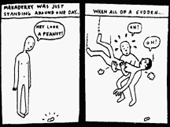

d. They might want to deal, but not want to talk about what went down. Common sense tells us that talking things through makes them better, and that’s probably eventually true in most cases. But folks who study Post Traumatic Stress Disorder (PTSD - a chronic psychological condition that comes from trauma, including intimate violence) say that if someone’s just been through some really crazy shit, it’s not the best thing to make them describe it all right away. The most important thing is to do whatever they need to calm them down, soothe them and make them feel safe as soon as possible. Then they talk when they’re ready, and maybe they won’t be ready for a while – it could even take a month. In the meantime you can do not-talking-it-out kinds of support for them.

e. Think about what you’re willing to do before you offer. ’s are dealing with a lot of shit and can be overwhelmed and confused and need a lot of different
8

If you just kicked ⬇ out
Change the locks on the house, car, or bicycle. Think about anything else that you share with ⬇ (like a bank account, the darkroom you use, your locker at school), and arrange things so you don’t need ⬇ to get access to it, and make sure ⬇ can’t get access anymore. Think about going to school or work a different way for a while, or changing your work hours if possible. A restraining order can be useful if you don’t have friends who can hang out with you all the time, but remember that means not only that ⬇ can’t contact you, but you can’t contact ⬇ either. If you contact ⬇, the temporary restraining order (TRO) is longer in effect.

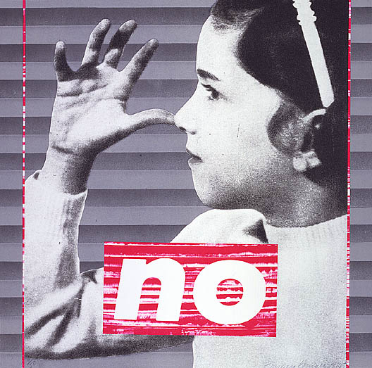

33

Safety precautions around leaving an abusive relationship

Remember that leaving is the most dangerous time in the relationship. Even if ⬇ hasn’t been physically abusive up til now, that doesn’t mean they won’t start. Seriously. People get agro and do crazy shit that you might not expect. So if you’re encouraging  to leave, make sure they have a support network to back them up. If  doesn’t and you can’t help create one, at least help them figure out other places they could go, like women’s shelters, a friend’s house, New Zealand, etc. And show  these safety suggestions (To look at more detailed escape plans go to www.dccadv.org/safety.htm.)

Suggestions for 

If you’re still just thinking about leaving
If you think that ⬇ is going to seriously freak out if you leave, consider making a plan for how you’re gonna take off before you actually do it. Save a little money, and put together a get-away bag (with extra keys, clothes, meds, ID, important documents, phone numbers, and anything else you really want) and store it with someone you trust. Ideally somewhere that’s not the first place ⬇’s going to look for you. You can also create a false trail to make ⬇ think that you’re going somewhere you’re not going to go. Remember that any phone numbers you call from your house will show up on the bill later.

If you just left
Take a time out from being around ⬇. If you need to get stuff from the house or talk to ⬇ or be somewhere ⬇ is, take some people along with you. Consider asking for accompaniment either for yourself or ⬇. If you don’t want ⬇ to know where you’re staying, be careful who you tell where your new pad is. Depending on how wigged out ⬇ is, ⬇ might threaten people who ⬇ thinks might know where you are, and it’s hard to know how people will respond when they’re threatened, so be aware of that when you share information too.

32
things. You get to decide how much you can handle. Its better to start slow than to suddenly back out on someone because you got swamped.

f. Look at the power dynamics. Gender difference is obviously not the only factor that causes power imbalances in a relationship. Race, culture and class (etc. etc.) are also factors that affect not only power but also safety, communication styles and access to services. We decided to refer to power dynamics in general terms throughout the zine, but we encourage you to keep concrete examples in mind as you read along.

Can this be used for situations where ⬇ and  didnt ever have a close relationship?

- What we’ve written is designed for crises involving people who are/were intimately involved in each other’s lives, so a lot of what’s in here wouldn’t apply to a situation where folks don’t know each other so well. The fact of having a connection can create a mixed bag of emotions – guilt, anger, love, longing, frustration, tenderness, confusion, or just all around crazy. It can make people put up with funk they wouldn’t necessarily take from someone they didn’t know so well. They (⬇ or ) may not recognize the bullshit or might excuse the behavior in a way that people involved in a stranger or acquaintance assault probably would not. It’s very likely an ongoing dynamic, although the people directly involved in it might point to a single incident. One of the jobs in supporting people around intimate violence (transformative support) is to get both  and ⬇ to look at that dynamic and what part each person played in it, and take responsibility for their own piece, in order not to have to suffer the same hell again later. If  didn’t really know ⬇, then a lot of that stuff doesn’t apply. But keeping that in mind, the suggestions for coordinator, physical and emotional support would probably still be useful.

9

S U P P O R T R O L E S

We divided support into four main categories – physical, emotional, “transformative” and coordinating. That doesn’t mean you need one person for each kind of support; stuff can and will overlap. And for some categories you may need several people (remember not to take it all on yourself!). ⬇ and  should have different support teams, and their support will look a little different, but all four roles apply to each one (as long as they’re willing to deal with their doo-doo on some level).
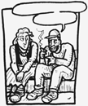

Coordinator

Depending on the situation, there could be a lot to do, and it makes sense to have one person who’s making sure everyone is communicating with each other, and that the supportee’s needs are getting met. For the people who are doing support up close and personal, it can be easy to lose track of the bigger picture, so it makes sense for a coordinator to keep tabs on the original support plan, and whether it’s being followed. They can try and find relief support if/when others start to burn out, help facilitate meetings or look for facilitators, and provide contacts to counseling services or other outside resources. The coordinator could also arrange meetings within or between  and ⬇’s support teams to generate ideas and help each other out, or to help prevent a civil war from starting.

Physical

Includes: For either  or ⬇
• a place to stay/housing
• food
• money
• childcare

10
If ⬇ refuses to engage with you at all despite your best efforts, or if they are still being violent, you have little option but to exile them in style (this could include baseball bats). Make sure you put the word out about the asshole to other communities so the individual can not pull the same shit there.

Story # 4

Jean and Tony were living in a collective, anarchist-identified house. One day they got into a fight over ice-cream. There were lots of other people present. First, Jean was complaining about people eating all the ice-cream. Tony made fun of Jean, then Jean yelled at Tony. In response, Tony threw a small wooden object at Jean, which hit Jean's boyfriend in the head. So Jean went up and slapped Tony in the face. Which gave Tony the impulse to throw a large heavy bowl of oatmeal that hit Jean and left a deep gash in her arm. Jean had to go to the hospital to get stitches.

Later, the house sat down to discuss what had happened. Jean apologized for slapping Tony but Tony didn’t apologize for throwing things. He said he thought violence was an OK way of resolving conflict. The rest of the collective decided that they were equally responsible for what happened, so nothing needed to be done. Jean wanted the house to make Tony leave, but people did not feel comfortable kicking him out, partially because of the fact that Tony was gay and latino, and everyone else who lived there, including Jean, was white. Jean moved out soon afterwards because she felt unsafe living with Tony.

Jean is the person who told me this story (and gave permission to use it here), and afterwards I asked her what people in the house could have done to make her feel safe enough to look at her own part in the conflict. She said that first of all she thought if Tony couldn’t even
apologize, he shouldn’t have been allowed to live there. In addition, she had wanted some acknowledgement of the different degrees of violence involved. She knew that slapping Tony was wrong, and would have been willing to go into counseling (or something else), if the house had been able to acknowledge that what Tony had done was more harmful and dangerous than what she had done.

31

How to deal with reluctant jerks

Not everyone is going to come running arms wide open to embrace this process. People have a hard time facing up to their shit. You very well might encounter someone who refuses to be part of any healing process. Here are some ideas that might help encourage them. We also included an article at the end of the zine that talks more about strategies for helping ⬇.

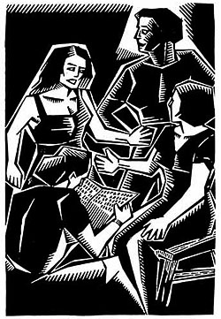If you can find people who are close to ⬇ and think that what they did was fucked up and needs to be addressed by the community, have them talk with each other. It’s important to express care for ⬇ and let them know you want them to stay around. It may take a lot of discussion over a long period of time to get ⬇ to agree to work on their shit. If no one is close to the reluctant person then have someone who is at least semi-neutral talk with them.

Another strategy is to get a group of people from the community together, preferably including ⬇’s friends, and invite them to a discussion about their behavior. Make sure to tell them that you care about them as a member of the community and want to see that all members of the community are safe − you get more flies with honey than vinegar. Also let ⬇ know that they have a variety of options around support; come with suggestions such as transformative support with a friend, therapy, anger management classes, etc. Finally, ⬇ gets the choice of working with the community and dealing with their shit or getting asked to leave.

30
• medical attention
• accompaniment
- to and from work, home, or other places they go a lot
- at home, meetings, shows etc.

For 
• people on call in case of emergency
• someone to talk to neighbors/community members/housemates to let them know that
⬇ is unsafe and/or 86’d for the time being.

Most of the time in domestic violence when we think about  leaving an abusive situation, we imagine them moving out of the house, staying with a friend, maybe even moving to a different city. Basically becoming homeless or going into hiding and screwing up their whole life in order to feel safe. Sometimes that’s necessary, but safety could also be achieved by getting ⬇ another place to stay, a “bodyguard” etc. Accompaniment is a lot of work, and isn’t always necessary, but it might be important for  to feel safe/supported etc. If  is asking for escort service (for either themselves or ⬇), it’s a good idea to do it, at least for a while, even if it doesn’t seem like that big a deal to anyone else.  knows the most about their own situation, and if they’re afraid for their life/safety, they probably have more than good reason to be (42 percent of all women who are murdered are killed by an intimate partner).

❐ might also just not want ⬇ in their face. Depending on how public a space ⬇’s getting banished from, this can be one of the hardest things to negotiate, (especially if  isn’t comfortable talking about what happened yet) because it means everybody and their mother gets involved, and starts throwing their two cents all over the room. But exiling ⬇ from a house/organization/infoshop/practice space doesn’t have to last forever. Usually  and ⬇ can go back to standing to be around each other after everything calms down (though it could take a while). Proposing that the expulsion last for a month or two, and then be reviewed, could prevent the decision from feeling like a life or death situation that requires everyone to start screaming and getting defensive.

11

Emotional

Includes: • listening to them vent
• assuring them you’re there to help them out
• talking them through their support/safety plan
• encouraging them to ask for what they want
• helping them express their emotions safely

Emotional support is a role best filled by (a) good friend(s), or at least someone who gets along with the supportee, in case they’re isolated and don’t have a lot of best buddies around. The emotional support person (ESP) can also challenge the supportee to look at their shit, but the ESP’s main job is to help ⬇ or  feel safe enough to do what they need to do and continue working stuff out in therapy, mediation, transformative support, how-not-to-be-a-violent-asshole classes etc. It can be tricky, but you want to try and be nice to them, without excusing their unhealthy behavior, or vilifying the other party.

When you’re the ESP for  it’s good to remember how complex their emotional soup could be at the moment. Most likely there were good parts that kept them in the relationship with the other person, and they probably miss them, even if all they’re telling you is what a jerkoff that person has been for the last 6 months. They might be confused and just want to hibernate and not deal with anything. Part of your job is to lay out a bunch of options and help them talk out what their needs are, because they might not be able to articulate them very well. But it’s important that, if they want support, they be the ones who decide what that support is going to look like. Don’t make decisions for or push shit on them. Their empowerment process includes taking responsibility for their own life.

12
Sometimes rumors can get out of control and everyone in the community may be talking shit. At times like this it is helpful to get groups from both sides together to talk about what really happened. Make sure to have a good facilitator. Participants in a get together like this can be encouraged to bond with each other, remember that we’re all in the community, and we all want what’s best. Everyone can then decide to not participate in the rumor mongering and tell others to shut the fuck up.

Story # 3

I had a friend, Sammy. An old friend of hers, Frank, and his girlfriend Emma, got evicted and needed a place to stay while they found another space, or figured out if they were leaving the area, or decided to get into rehab for their heavy meth use. Frank, despite the concern, frustration and anger of many of his friends, had been hitting Emma. Emma, despite the concern, frustration and anger of many of her friends, didn’t want to leave Frank.

Sammy wouldn’t let Frank hit Emma while they were staying at Sammy’s place, and talked to the two of them about their relationship, but never felt like there was much response.

A lot of people got mad at Sammy, since they thought that Sammy was supporting Frank and Emma’s inappropriate relationship by housing the couple. Sammy thought that it was better to have them housed than on the street, and that Frank hit Emma less while they were living with her.

The couple ended up moving into a rural area and they still use drugs but not as much as before, and there doesn’t seem to be any violence, although it’s hard to tell.

29
How do you Talk About a Conflict with Other People?

As a support person in a situation you might have a lot of people asking you questions about what happened. How you answer those questions will in part determine what rumors get circulated. It is important to be honest and not alarmist. This can be hard to do if you are pissed at either person, but remember situations are rarely if ever improved by lynch mobs out to get “the bad guy”.

It is also important to ask the supportee how many details they want revealed. They may not want everyone all up in their business. Or they may not know what the hell they want. If this is the case give them some options, such as; Is it all right to tell people about x, y and z? Should I not tell any details and just say that you are both having a hard time? Are there any people you do/ don’t want to know anything?

Be as specific and clear in what you are asking as possible. Make sure you take the time to encourage the person you are supporting to be clear with you about what they want. This often is extremely difficult to do without guiding them in one direction or another, but with time and patience the supported and his/her support group can figure out what will work. It can be a difficult balance to reach because support people have their own ideas about sharing information and secrecy, and their ideas have to be respected − if not necessarily catered to.

28

As an ESP you can help folks unlock their box of feelings without being crushed by what falls out. You can hang out with them while they’re doing emotional push-ups, assure them that they’re supposed to be feeling crazy right now, and try to help them figure out which emotion is trying to sneak out at any given moment. Its not always that obvious – women tend to mask anger with sadness or depression, and men cover both fear and sadness with anger, so if they’re down for it, you can explore a range of different activities and see what happens.

FEAR • don’t be alone
• hold a stuffed or living animal
• turn on the night light/sleep with a friend
• review support plan
• ask them what else they need/want to feel safe
• have the support team meet with them, just to tell them “we’re here for you”
• take a self defense class/martial arts
• write about it

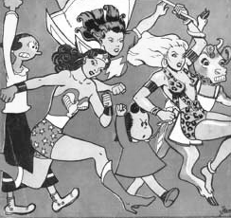

13

SADNESS • crying is good
• acknowledge that they’ve experienced loss- even losing a really fucked up relationship counts as loss
• if y’all are into rituals you could have one where they say goodbye to the other person/that dynamic, or write a letter they’re not gonna send, etc.
• draw pictures, paint, write poetry

ANGER • hit pillows or punching bag
• go running, jump in a mosh pit, or do some other heavy physical activity (without hurting self or others)
• break glass bottles somewhere where the baby raccoons won’t step on them
• scream/sing along with your favorite cookie monster band

DEPRESSION
• wake them up and make them go for a walk with you
• go out dumpster diving/to the woods/to a party/to eat
• let them sit, but not forever
• jump up and break something
• read poetry together

When you’re the ESP it’s important to be aware that this is a vulnerable time for the person you’re supporting. Physical contact can be especially complicated. Even things like hugging, back rubs, holding hands or snuggling, that might seem harmless, can trigger bad memories. They might want to be comforted and at the same time feel freaked out by being touched. So ask before you touch.

And in the process of doing a lot of emotional work, y’all might be tempted to get involved in ways that you won’t feel so comfortable with later (or sooner), in which case its pretty much impossible to keep doing support. So be careful and think before you act (see page 27 for more on rebounding).

14
bad parts, but the good parts of the relationship are often left out of the story when a person needs support. So to avoid losing your mind and all respect for your friends you have to keep in mind that the process is more important than the outcome.

If you start to feel like you know exactly what should happen then the people you are supporting can lose their own agency to make a choice through your pressure. This can keep people trapped in victim mode where they feel disempowered. It’s also stressful for support people because you are then required to carry the weight of making decisions for another person. In the end this will make you tired and the other person will not truly make their own decisions which is important so that people can get into better relationships in the future, rather than repeating the same old shit.

Another situation that often comes up and can lead to more trauma and drama is when sexual intimacy is initiated between you and the person you are supporting. When people come out of fucked up situations they are often looking for security and connection with others. This can leave them extremely vulnerable and make them turn towards you for that connection. Sexual intimacy is one way to create a connection with someone but if you find yourself feeling those feelings, back off and wait until the person has been out of the relationship for long enough to have a clear head about what they want in a relationship with you.



27
Taking Care of Yourself as a Support Person

First off, when you become a support person you are taking on a fucking huge responsibility that takes a lot of time and energy. So if you start feeling stressed out be sure to take the time to take care of yourself. Remember you are not perfect and you are not responsible for saving lives or keeping people from being more broken. You are there to remind them of what healthy, respectful relationships can be like, (see page 38 for some ideas) and to encourage them to remember who they are, and who they want to be. Mistakes happen often, especially if the person you are supporting is unclear about what they want or need, so don’t be too hard on yourself.

Violence is traumatic for everyone involved, even the support people. When you take on this work make sure you have a space to react to the fucked up shit you are going to hear. It’s best if you can react to it when you are not around the person you are supporting; they usually have too much on their minds to support you (although occasionally they appreciate knowing that other people get freaked out by this stuff too).
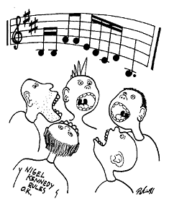
A way to help yourself not feel overwhelmed is to keep communicating with other support people. This may mean a meeting (or better yet a dinner party) where all support people get together and talk. It is important to be able to call these support people if you feel overwhelmed and can not do something. This also involves knowing your own limits and letting others know where your limits are.

One of the hardest things to deal with is often the aftermath of the situation. It can seem really fucked up, and support people can feel really fried and pissed off, if the couple decide to get back together. As a support person you will probably hear most of the dirt and frustrations which make one outcome seem the only sane way to go. Relationships are rarely made up of all

26

Story # 1

My involvement with this story begins when I was asked to come to a meeting about an act of intimate violence committed by an acquaintance of mine. A friend of mine had called for an intervention and at first the situation seemed very clear. The couple had been together for several months and had become increasingly isolated from their friends and had begun to fight and make-up regularly. During one of these fights he struck her. During the intervention she recounted how he had first pushed and then slapped her. He apologized, kept his eyes downcast and admitted to everything. I remember thinking how typical this display of remorse was for an abuser and hoping that the other members of the intervention would not take it easy on him just because he seemed remorseful in the moment. They didn’t. They really went after him. She said she was grateful for all the support. He cried and said that he thought he should leave the relationship, seek counseling and exile himself from the community for a while. It was all going the way I pictured it.

Then it shifted.

She began saying that she wanted to stay with him in order to help him work on his issues. He said he was unsure and didn’t want to hurt her any further, but also didn’t trust himself in this relationship. When some folks suggested it might be good for them to separate, she grew increasingly angry and said maybe she didn’t need community support anymore. Someone said that at least they should check-in with folks and talk about what their increasing conflict was all about. She stated that it was personal. He was silent. He finally said that if she kept her promise to quit drinking he would stay. She said that she didn’t have a drinking problem.

As the conversation continued what came out was her pattern of alcohol abuse, verbal abuse and her tendency to break things around the house. His attempts to take care of her, to “save her,” and to intervene when she was drunk, was what had led to the incident. His own history of taking care of alcoholic parents also came up. At the end of the intervention it was clear that while his hitting her was completely unjustified, things were far more complicated than they had appeared at first.

15

Transformative

Includes: • listening without judgment
• helping them get some perspective on their situation by writing down the history of abuse
• looking at the patterns of intimate violence
• challenging them to see what roles both they and the other person played
• helping them figure out what they want their life to look like and what steps they can take to get there

- Before we get into detail, we want to warn y’all that doing transformative support requires a set of skills similar to the ones used for counseling, mental health work, and survival on the street. If you and your pals are interested in learning this kind of support, send a couple people to a training, for example, the kind of trainings done by suicide prevention hotlines, by some domestic violence shelters for volunteers, etc. Then do some role plays, and practice on each other before you try it in the real world. It’s not nice to use people who are freaking out as guinea pigs. You still won’t know what the fuck you’re doing until you have some experience actually doing it, so if possible pair people up with that in mind (for ex. hook up book learning folks with folks who have street smarts). You can also look to join forces with a friendly neighborhood mediator or therapist to do this kind of support, but be aware that this isn’t a process most “normal” people and organizations would be familiar with, or endorse. Transformative support is different from therapy ‘cause it focuses on the present/future rather than the past.

- Just like everything else, TS is a team sport. Since you don’t get to talk to anyone outside the process

16

Story # 2

Darren moved from Sacramento into our house. He had been a friendly acquaintance but not someone we knew well. Shortly after he moved in, a situation involving his prior partner (Velma) erupted. People who knew about the situation began ignoring Darren at social gatherings. When it became more public that something was going on, Darren told us that while he was in Sacramento, he had a bad fight with Velma, during which he asked Velma to leave, and when she didn’t, he broke his hand punching a wall, and then threw a bike. She left and that was the end of their relationship. Velma had a history of mental issues, and in addition to being her romantic partner, Darren was also an important support person for her. Darren was very upset with the current situation and the way he had acted. He agreed to anger management classes and to seek counseling as well as to continue checking in with us about how he was doing.

Velma wanted no contact with Darren. She processed by doing a zine which outed Darren as a “sexist and violent abuser” and called for his banishment from the community. Velma and her support team were very upset that we were continuing to engage Darren and maintain a relationship with him, but they didn’t contact us directly. We heard about their feelings fifth hand – that we were “harboring a violent abuser in our sexist sanctuary” or words to that effect.

We organized a sit down with Velma and her support team, and our household. We articulated our support for her and her process, but explained that we believed that there were many different roles to be played by community in these situations. We felt we needed to be engaging Darren to give him the support he needed to heal and to modify his reaction to anger. Velma thought that we were not being supportive and were contributing to her mental health problems.

I was concerned about people talking lots of shit behind Darren’s back without doing anything to make the situation better, and then saying that they were fighting sexism. This kind of activity seems to me to have made the situation much harder for those directly involved.

25
Inter Transformative Support team communication can be tricky. Beware of butting heads, and playing out the conflict yourselves. Or ⬇ and  playing y’all against each other. Beware also of conspiring amongst the two teams to mastermind the situation. Regardless of how unhealthy you think ⬇ and ’s process is, it has to be about their agenda.

Mediation
Mediation could be a part of their plan around figuring stuff out, like who gets to keep the bass amp, or visitation rights for Polly the pit bull. Be aware that a lot of mediation services won’t touch domestic violence conflicts with a ten-foot pole for the very good reason that it might not be safe (physically or emotionally) for  and ⬇ to be in the same room together. There are lots of other ways of figuring that stuff out that don’t involve mediation, so neither person should be pressured into doing it if they’re not actually really and truly interested.

Mediation can also be a good way of resolving a conflict before the shit hits the fan. Either way, mediation is a somewhat complicated process, so the person doing the mediation for ⬇ and  should have plenty of experience both with mediation itself and with domestic violence issues, or you’ll end up doing more damage than good.
24
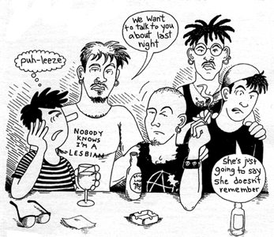about the stories you’re hearing, it’s important to be able to decompress with another TS person. Listening and sitting quietly with your emotions while someone is telling (or denying) the gruesome details of abuse is hard work. You’re gonna need an escape valve. If you try and swallow it, be assured that it will come out later in some totally inappropriate way during one of your sessions. Also, you need to be able to check each other if shit gets out of control. Like if you start either hating or loving the person you’re supporting. It’s super common for people doing this kind of work to end up falling madly in love and sleeping with ⬇ or . When people are that vulnerable, and in the middle of trying to figure out major relationship drama, it confuses everything, as well as fucks up your credibility as a support person, to have sex with them. Besides playing into the dynamic that got them there in the first place. So if you start to feel the urge, check in with your other support person and give yourself a break.

- Each transformative support team (TST – one for  and a different one for ⬇) would ideally be made up of two people who have some degree of neutrality in the situation. If you identify too much with the person you’re trying to support, and you’re going to believe everything they tell you, don’t do it. If you get too sucked in emotionally you’re not going to push them to look critically at what they went through. For ⬇ most likely you need to get past some serious walls of denial, and for  you need to get them to take responsibility for their own actions, without blaming them for what went down. At the same time,  or ⬇ has to be able to trust you enough to spill their guts and believe that you aren’t going to go put their story in the next issue of Maximum Rock and Roll.

- But if you’re too neutral and can’t identify with them at all, then you might be too much of an outsider to really understand the process, or the community. The people who do the best transformative work have wrestled their own inner demon(s) and come out on the other side. They’ve been through a transformative process (not necessarily around intimate violence, it coulda been addiction or severe depression, etc) and know what to expect from people during the different stages of a crisis.

17
- Crises are cyclical, just like most other things in life, and the stages look pretty much the same for both  and ⬇. It’s good to try and identify what stage they’re in, and remind them that they’re going to have major ups and downs during this process. During the crisis itself, people go into survival mode, but that can’t last too long because eventually their adrenaline runs out. Then comes shock. Things have calmed down, but they might feel out of control, depressed, or bottomed out. If they start to deal with stuff,  will likely feel safer, and ⬇, guilty. Continuing to deal leads to the treacherous honeymoon stage, where they might decide that they figured it all out. They’re making progress in therapy, there have been apologies, they miss each other, then, wheee, let’s get back together (or start a new relationship with another equally charming person). Eventually, and it may not take long, something bad happens again. Now on top of whatever ingredients that particular event is made up of, they feel betrayed, either by themselves or by the other person. This leads to new lows of feeling anger, fear, depression, and failure, and can be a dangerous time. The trick is to know that there will be inevitable highs and lows, and to be able to push through them without having unrealistic expectations.

- Transformative support (TS) shouldn’t start until things have cooled off (adrenaline tank on low) and they’re ready to be reflective again. Remembering all the most awful moments of a relationship is a pretty intense thing to do, and in fact can be re-traumatizing if you do it too soon (some folks who study PTSD – Post Traumatic Stress Disorder – say that ideally folks should wait 2-5 weeks before describing a traumatic event in any detail). So wait until the crisis is over and they’re getting some of their safety bases covered by other members of the support team, and they really feel ready to talk about it. Then buckle yourself in good, ‘cause it’s gonna take a while. The crisis itself will probably last no more than 1-2 weeks, but the process each person needs to go through to really change takes years. TS is the middle ground. You need to be able to commit to working with ⬇ or  for at least 3-6 months (after that you might be done, but they’re not). Your job is to help people keep dealing in that initial period until you can hook them up with some rockin’ long term support (see step 6 for examples of life changing activities).
18
(without giving advice), and then respect whatever it is they decide to do. The only way to learn how to make good decisions is by making them yourself.

For ⬇
⬇ can generate ideas for their plan, and so can  and people in the community too.  will most likely have specific requests or restrictions for ⬇. If the whole affair is public knowledge, folks in the community might decide that in order for ⬇ to get to go to the crochet-your-own-black-hoody classes, ⬇ has to respect ’s wishes. And there needs to be some way of making sure ⬇ is actually sticking to the plan. ⬇ might be accepting the accountability process in good faith because they really want to change, or ⬇ might be dragging their feet, or ⬇ might be lying their head off in order to get whatever carrot is hanging at the end of the plan-stick. Regardless, ⬇ needs to have someone checking up on them to make sure it’s all coming along good.

Communication between teams

Obviously  and ⬇ each have their own, separate transformative support team. But it’s important for ⬇ and ’s teams to be talking to each other during the whole TS process. ⬇’s team needs to know where to push, and how to help ⬇ formulate a realistic plan. If ⬇ wants to join the radical cheerleaders as a way to get out excess aggressive energy, it would be crucial for ⬇’s team to know if  is already in that group, and had specifically asked ⬇ not to come around. Support team info sharing also helps find inconsistencies, and keeps ⬇ and  more honest. Especially if they’re staying together. Most everyone will flow you a certain amount of bullshit. Don’t take it personally. It’s not because they want to, but people carrying 1,000 lbs of crap on their back are likely to sling you some now and then.

If ⬇ and  know that their own personal TST is also getting the other side of the story, it can help keep their story from becoming a great work of fiction. It can also help the TS team identify a cry for help. ⬇ may not be capable of asking for further restrictions or accompaniment. But if everyone knows that ⬇ is banned from Punk Rock Central for the next three months, and then ⬇ suddenly blurts out to you that they’re planning on going to the Neurosis show there this Friday, ⬇ might be asking for someone to help them figure out a way not to.
23
Step 6 – Make a plan
For both  and ⬇ (somewhere far far away from each other)
Talk about their options from here on out. Try and get them to focus on themselves – changing the other person is not their job. What are their goals and desires? What do they want their life to look like, both in the immediate future and in general? What do they need to do to get there? It could be anything from keeping a journal to kicking speed. Anything that reinforces living differently is good – hiking, martial arts, playing the tuba, living collectively, eating vegan, starting a new chapter of Copwatch, etc. If they’re depressed and are having a hard time imagining anything better, give them some examples of positive communication and relationship patterns. (For more on positive relationships see page 38). You can also refer them to therapy, self defense or anger management classes, mediation services, support groups, dumpster divers anonymous, etc, if any of those seem appropriate.
Write out the plan. Start out short and sweet. Don’t pile on too much. It’s important for the plan to be successful in order for ⬇ or  to want to keep the process going, so a small, simple plan is going to be more helpful than a big complicated one. It should include a timeline and support folks who are going to check in with them periodically. And it’s good to re-write the plan frequently, maybe even every time you hang out. Keep re-writing it to keep it both helpful and manageable.

For 
Get  to generate the ideas for the plan as much as possible. If they’re stuck, lay out other options without being pushy. Then do a reality check and look at the pros and cons of each option. It’s possible  is going to want to do something you think is stupid, like getting back with ⬇, and you’re going to be tempted to try and talk them out of it. Don’t do it. In the long run you’re not helping them out that way. Instead, walk them through the probable outcome of that decision
22

Step 1 – Find a good spot

This step is the same for both  and ⬇
The first thing you gotta do is to create a safe, comfy and private environment to facilitate open communication. If you’re in a dumpster, close the lid so other people can’t hear, and make sure the trash compactor isn’t going to barge in on you before you’re finished. Let them know that everything you discuss is 100% confidential, and that you’ve turned off your judgment-o-meter. This process is for them to heal/get better, and the best way to do that is to look really honestly at what happened, leaving all shame and embarrassment aside.


Step 2 – General approach
For 
Tell them you’re there to listen and help look for solutions, but that you don’t have any magic problem-fixing potions, and you don’t give advice either. Given the situation,  may not be trusting themselves very much, and they might beg for you to make decisions for them. Don’t give in. Use the force.

Challenge  to see their own role in the situation. This doesn’t mean that what ⬇ did was ’s fault, but  also needs to look at the dynamic in the relationship and if/how  was contributing to the funk. In order to prevent this from happening in the future,  needs to figure some stuff out for themselves, whether that means getting better communication skills, learning to set boundaries, or just figuring out how to recognize assholes from three blocks away.

Beware of the victim syndrome. People who have had their power stripped away will sometimes look for whatever teeny way they can to get some power back. And being hurt can be a way of getting power. The (twisted) logic goes: If you have been wronged, then you are right; if you are right, then you are good; if you are good, then you are lovable, etc. It doesn’t mean  went out and looked for someone to assault them in order to feel good about themselves, but once the violence already took place, sometimes  will keep pushing the victim button longer than is really helpful for them. The hardest part of your

19
job is to give that back to them while emphasizing their strengths. And without making them feel like a dust-mite. You might straight up ask them what they were getting out of the relationship. It’s important for  to know why they wanted to stay (for however long they did), so they can truly want to get out.

For ⬇
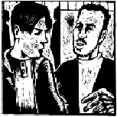
You’re going to have to push and dig. Remind them they’re here ‘cause they want to change, and that it’s only going to work if they’re really honest with themselves. If they don’t deal with what they did, they’re sentencing themselves to repeating it again later. One way of establishing enough trust for them to go there is to share stories from your own experience about fucking up and getting through it. It can be challenging to do that without sounding like you’ve got it all figured out (which usually is pretty alienating) but it’s one tactic.

Another way to get them to look deep into their bag of dirty laundry (which is hard even under normal circumstances for most people) is to walk them through the consequences. There’s a fine line between threatening someone and letting them know what the real life price is for not dealing. Like , ⬇ needs to go through their own process, and ideally they get that their life is fucked if they don’t pick up the pieces themselves. But personal growth isn’t always a strong enough motivating factor. You might need to remind them that their actions affect the people in the community, and if they don’t shape up, the community gets to affect them back − however it sees fit, and that might not be pretty.

Step 3 – Write down the history of abuse
For both  and ⬇ (in separate dumpsters of course)
You can be writing down their story while they talk, but whatever you write is for them to keep. Start with the very first fucked up incident they can remember whether it was verbal, physical, emotional or otherwise. If they
20
start with something physical, ask questions to see if they had any inklings that something wasn’t right before that – arguments, negative comments, emotional blackmail, etc. and include that stuff too. Continue through to the most recent events. During this part you are mostly listening and asking questions.

Include: • cycles of violence or patterns of escalation
• things they did to try and change/stop it
• feelings they had while living with the abuse
• why they think the abuse occurred
• their hopes and desires around changing the situation
• whatever they want to say about the other person, both positive and negative

For ⬇
Also include: • what are their triggers for violence?
• what are the positive things they added to the relationship?
For 
Also include • what were they getting out of it?

Step 4 – Take a break if you haven’t already Air out the dumpster, stretch your legs and dig around again to see if there’s any more chocolate.

Step 5 – Look at what you wrote
For both  and ⬇ (but not together)
Read the whole thing back to them and add stuff that got left out. Now you get to make comments.

• Review the cycle of violence and show them where you see that playing out in their story. Remind them that violence is a common social disaster. They don’t get to take all the credit for inventing these relationship patterns.

• Help them look at what part each person played, and where their own responsibility lies. Point out the spots where you can see their strengths, plus the things they did to try and change or leave the situation while it was happening. Talk about the beliefs and fears that kept them from taking off and helped them excuse the bullshit.

• Give them props for asking for help. Their feelings, desires and needs are important!

21

